**PROJECT**

**COMPARISON OF COVID 19 HOSPITALIZATIONS AND MORTALITY ACROSS VARIOUD AGE GROUPS BY WEEK STARTING FROM MARCH 2020 TO JUNE 2020 TO DETERMINE MOST TO LEAST VULNERABLE AS WELL AS FORECAST FOR NEXT 5 WEEKS**

**By** Pradeepika Ravala

**BAN 620: ADVANCED DATA MINING APPLICATIONS**

**PROFESSOR: Ms SUSAN MCDANIEL**

**BELLEVUE UNIVERSITY**

**JULY 28, 2020**

**ABSTRACT**

The outbreak of Coronavirus disease 2019 (COVID-19), caused by severe acute respiratory syndrome (SARS) coronavirus 2 (SARS-CoV-2) resulting in catastrophe for humans. The outbreak was first reported in Wuhan, China and has spread to almost all the countries. World Health Organization (WHO) declared COVID-19 as a Public Health Emergency of International Concern (PHEIC) on 30 January, 2020. With the outbreak and rapid progress, readily available epidemiological data are needed to guide strategies for situational awareness and intervention (Dey, Rahman, Siddiqi, & Howlader, 2020). In this study, we use descriptive statistics tools of line graphs to understand the vulnerable population group by studying the age wise hospitalized and deceased population group in USA every week starting from March 2020 to June 2020. In the paper to follow we used both SAS Enterprise Miner as well as SAS studio to visualize the curves as well as forecast the data for next five weeks. This study also gives a glimpse on the survival rate in hospitalizations among various age groups.

**TABLE OF CONTENTS**

|  |  |  |
| --- | --- | --- |
| 1. | Introduction | 4 |
| 2. | Data | 5 |
| 3. | Method | 5 |
| 4. | Step-by-step Analysis in SAS Enterprise Miner | 6 |
| 5. | Step-by-Step Analysis in SAS studio | 33 |
| 6. | Result Interpretation | 33 |
| 7. | Conclusion | 34 |
|  | References | 35 |
|  | Appendix 1: Excel data file | 36 |

**PROJECT**

**Introduction:**

Coronavirus disease (COVID-19) is an infectious disease caused by a newly discovered coronavirus. It spreads very quickly through human-to-human transmission and sometimes leads to death. World Health Organization (WHO) has declared that COVID-19 as pandemic. The virus has now spread across the world and almost all countries are fighting against this deadly virus and everyone is working to curb the spread as much as possible (Ragavi & Geetha, 2020).

The ongoing COVID-19 pandemic was confirmed to have reached the United States in January 2020. The first confirmed case of local transmission was recorded in January, while the first known deaths happened in February. As of June 24, 2020, the U.S. had the most confirmed cases and deaths in the world ranging around 23,47,022 and 1,21,228 respectively. By early May, the U.S. had processed around 6.5 million tests, and was conducting around 250,000 tests per day, but experts said this level of testing was still not enough to contain the outbreak (COVID-19 pandemic in the United States 2020).

Although, several studies in the context of COVID 19 USA have been reported recently by many researchers to understand and analyze the dynamics of COVID-19 spread, but there are very limited studies on age wise analysis of hospitalizations (Chauhan, Kumar, & Jamdagni, 2020). Looking at the limited availability of hospital beds and necessary equipment, it is necessary to analyze for the vulnerable population and take preventive actions to decrease hospitalizations. The data analysis on mortality rate will further add advantage to recheck the vulnerable population.

Based on the age wise hospitalization and mortality data collected from the CDC website, in this study we present the most vulnerable population to the effect of pandemic and help the officials contain the pandemic among the respective groups by initiating several remedial and precautionary measures before the impact.

**Data:**

The data available from gis.cdc.gov and cdc.gov through COVIDVIEW weekly update records contain about 180 observations starting from March 07, 2020 to July 04, 2020.

The data is divided into age groupings of 0-4 years, 5-17 years, 18-49 years, 50-64 years, 65+ years on both hospitalization as well as mortality. In mortality the details are much detailed, so we have adjusted the numbers as per the age groups to conduct the analysis. In hospitalization data, the data availability is per 100000 records, which were adjusted as per the population records obtained from census government to nearest round for easier analyzing. These are the adjustments made to the data.

The mortality data is based on the death certificates collected from various hospitals. The data is ever changing because of changing data receiving. Hence, the analysis is based on the data collected in July 2nd week and may not represent the same visualizations as the ones posted on the sites.

**Method:**

To analyze and compare the hospitalization cases as well as mortality cases, we are using descriptive statistics of line plots and time series variation to understand the curve. A descriptive statistic is a summary statistic that quantitatively describes or summarizes features from a collection of information, while descriptive statistics is the process of using and analyzing those statistics. This helps us in understanding the vulnerable population as well as analyze the peak season weeks of pandemic effect.

**Step-by-step Analysis in SAS Enterprise Miner:**

The first step is to start creating new project:

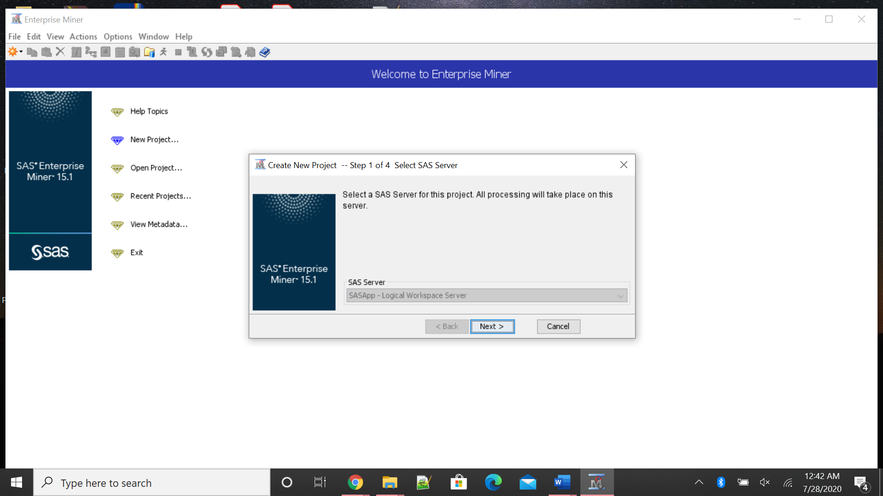

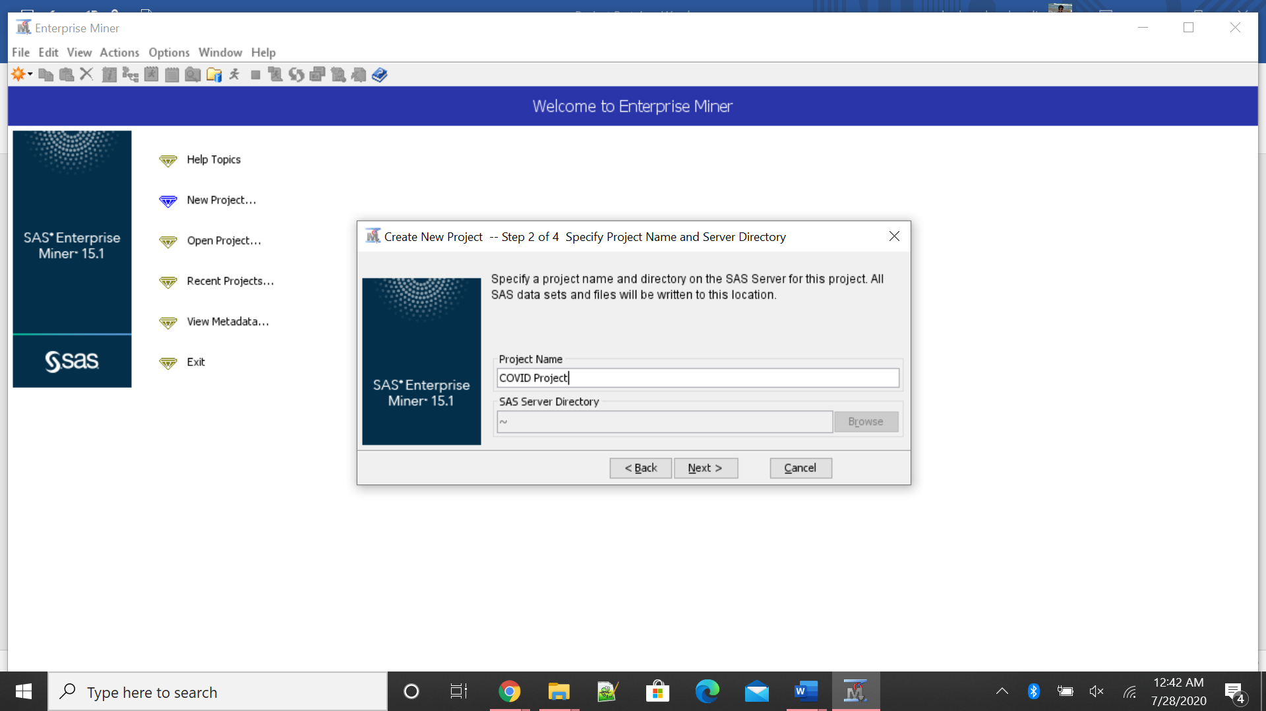

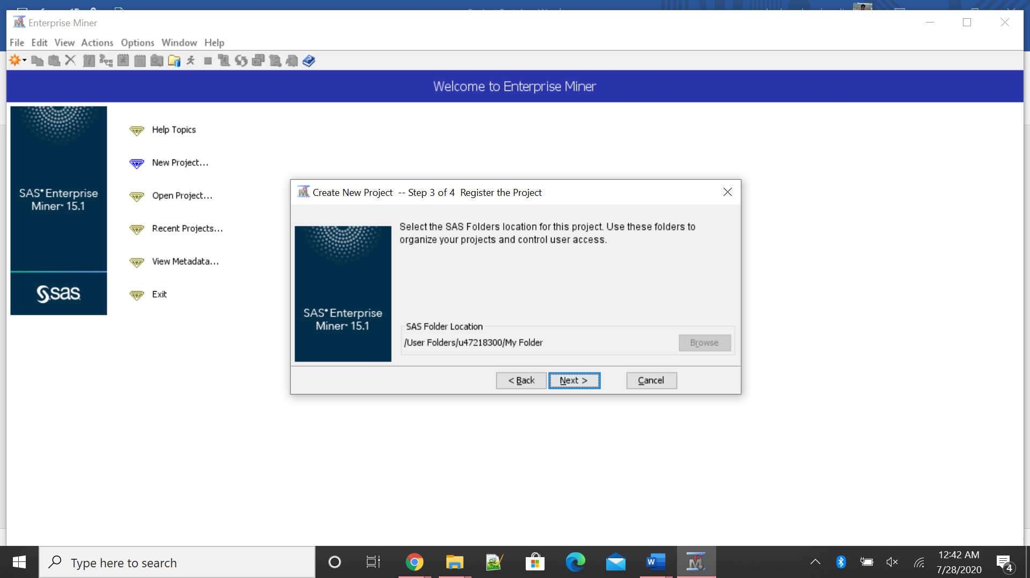

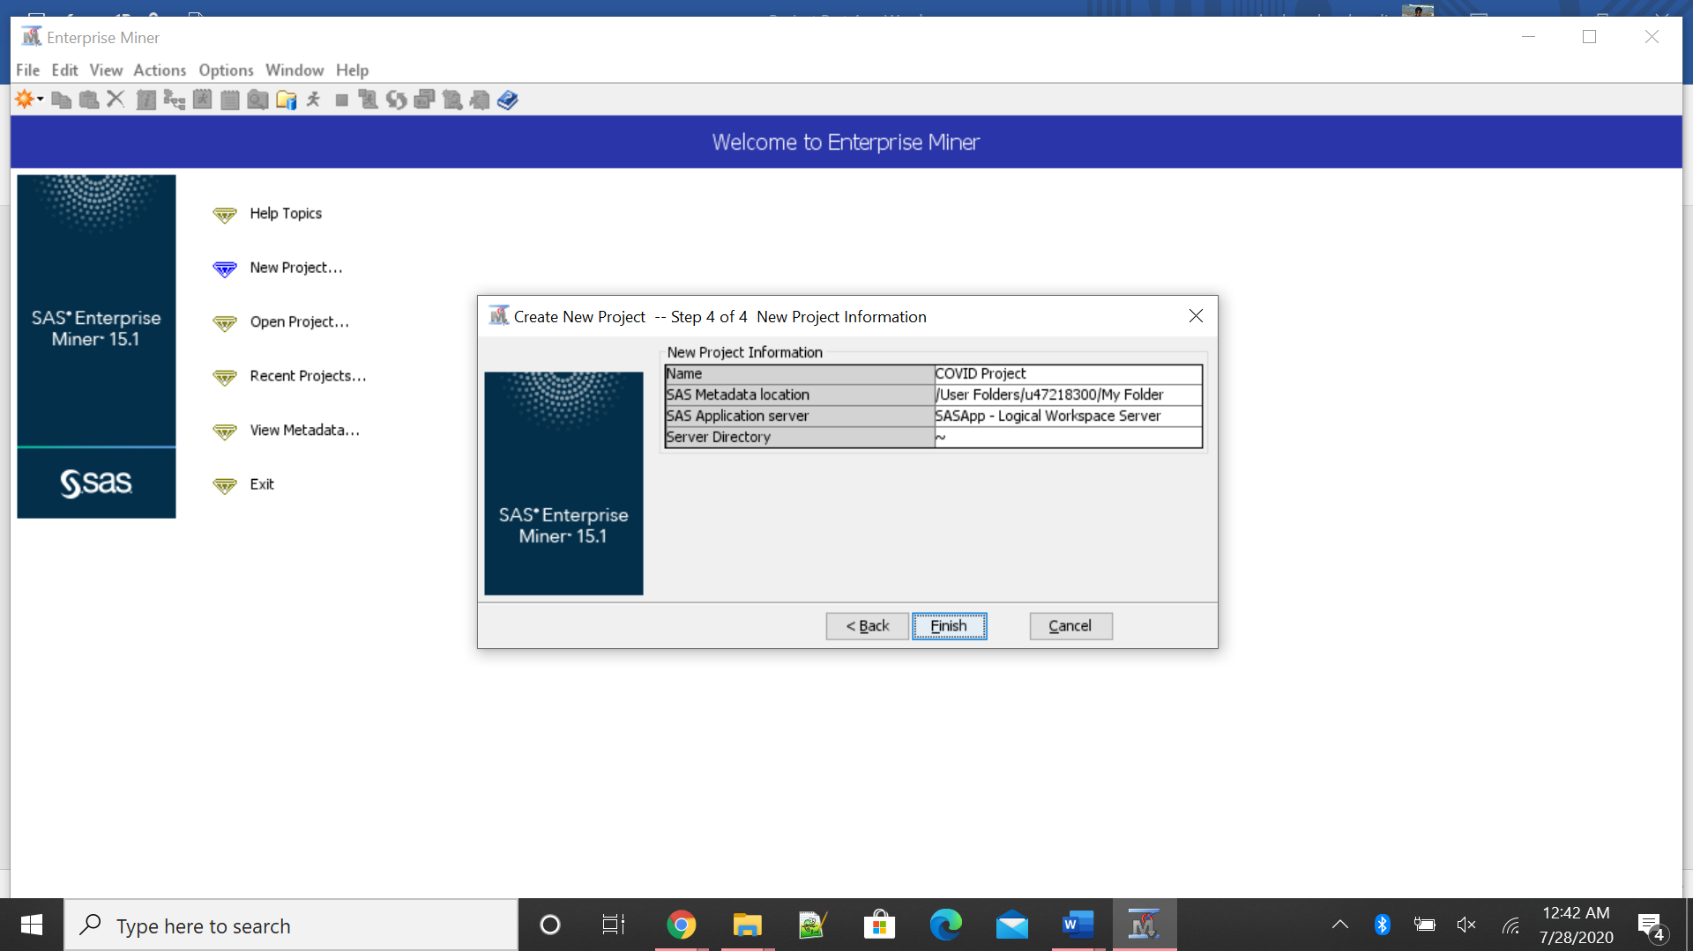

After creating the new project, the next step is to start creating a diagram for importing file and saving the same.

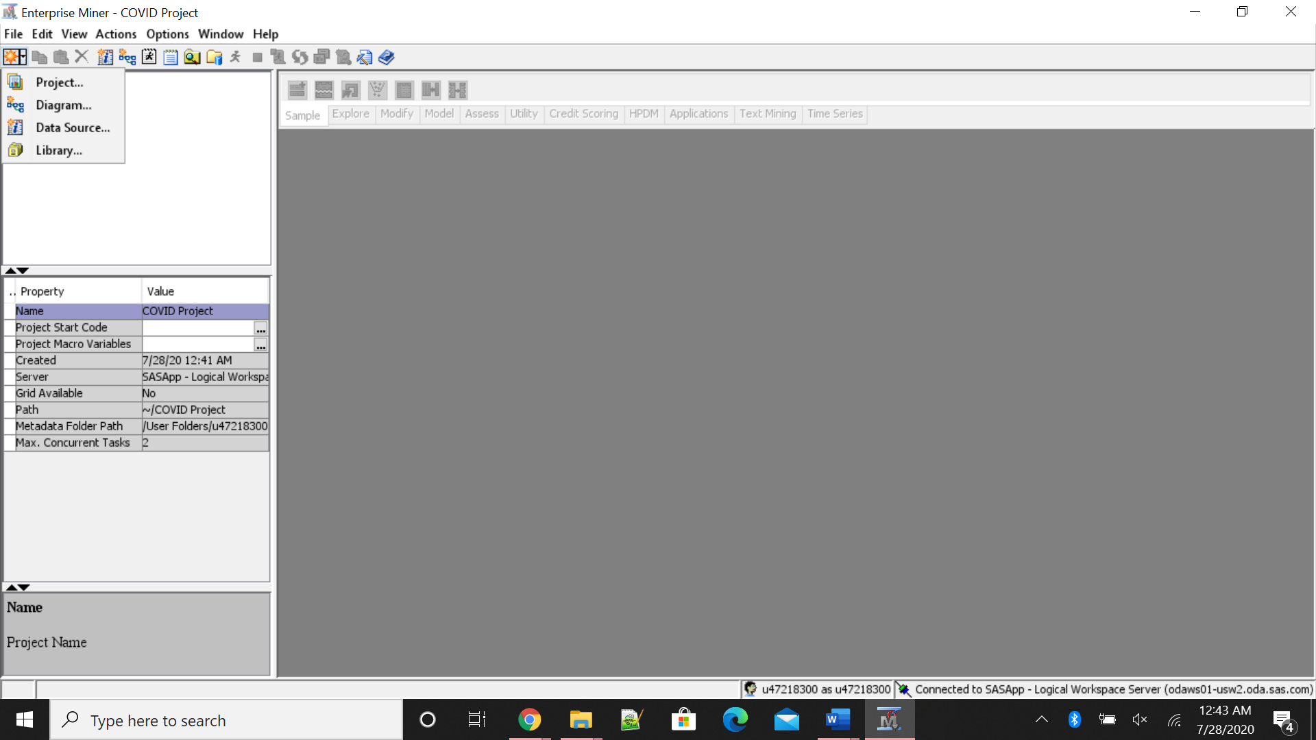

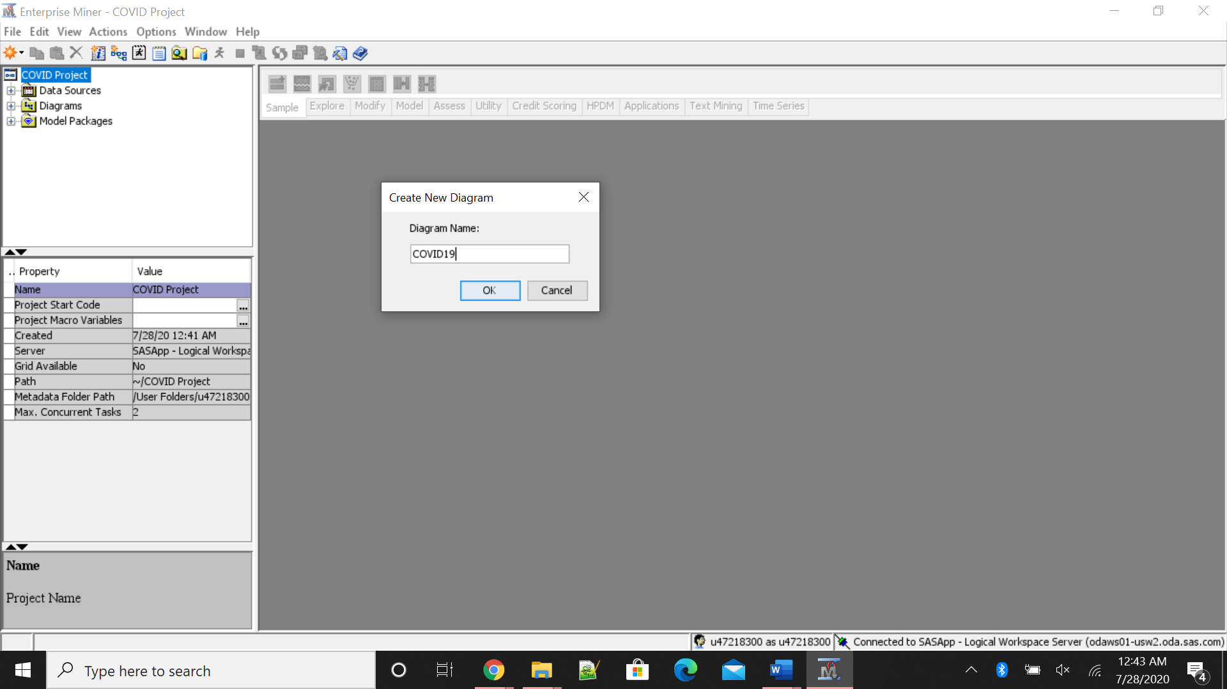

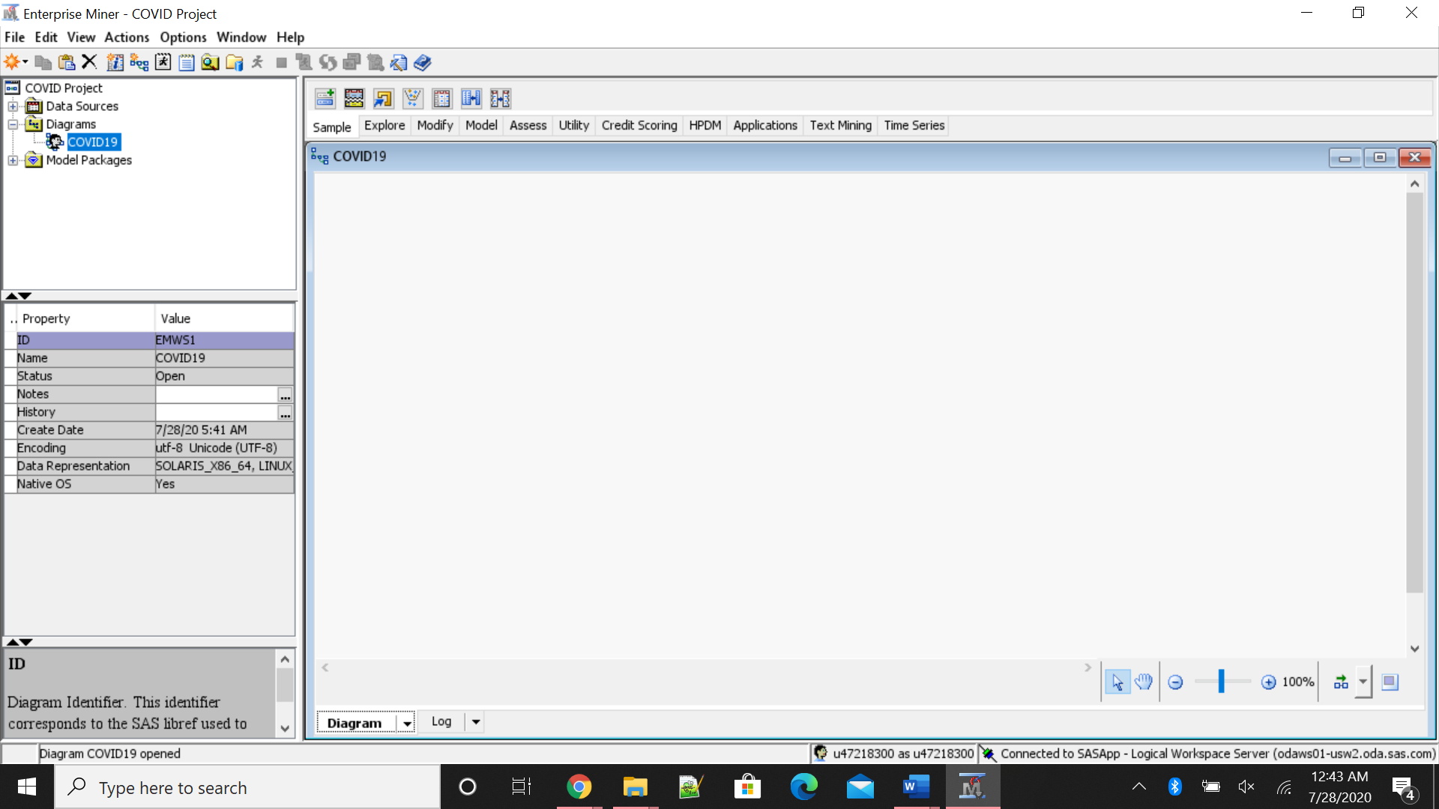

The following images provide details on how to import the excel or CSV file that contains the data that needs to be analyzed.

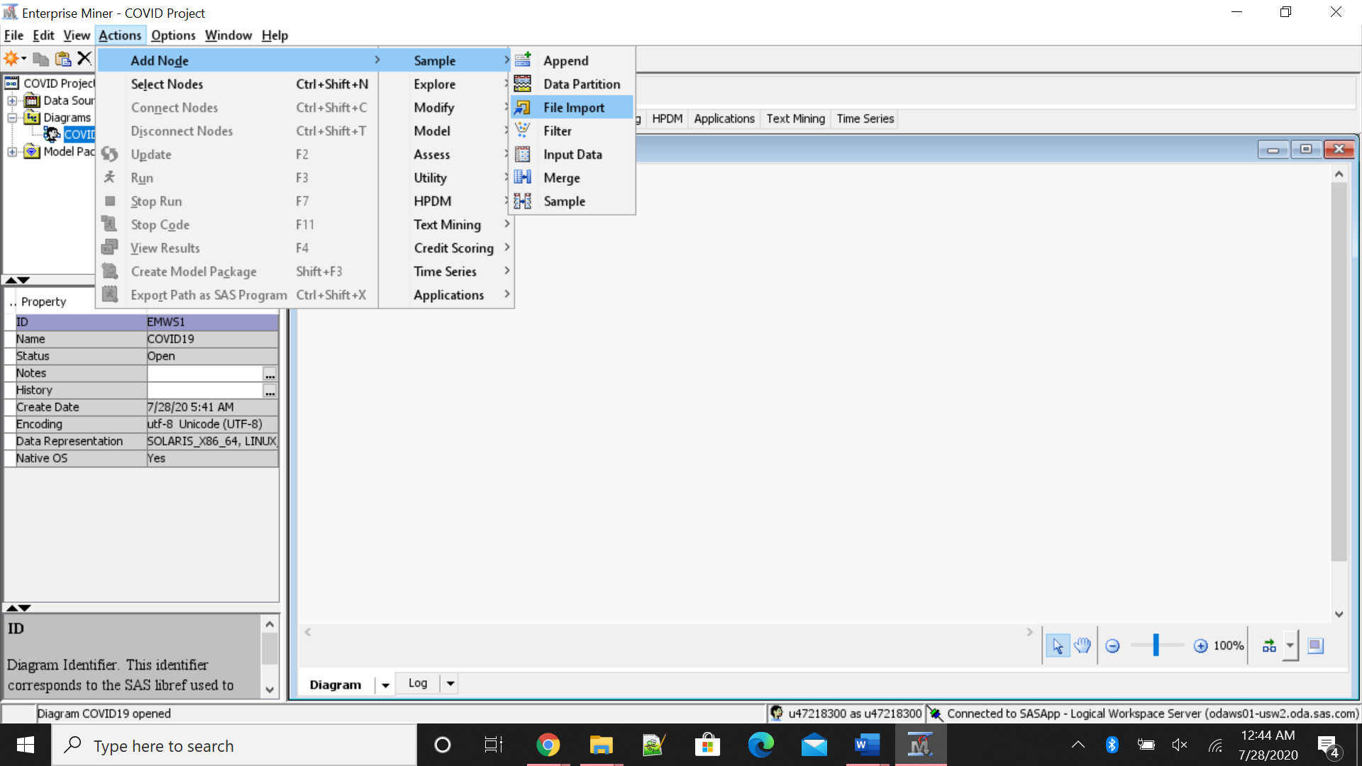

Once we place the icon, we have to change advanced advisor to yes in the properties panel of icon.

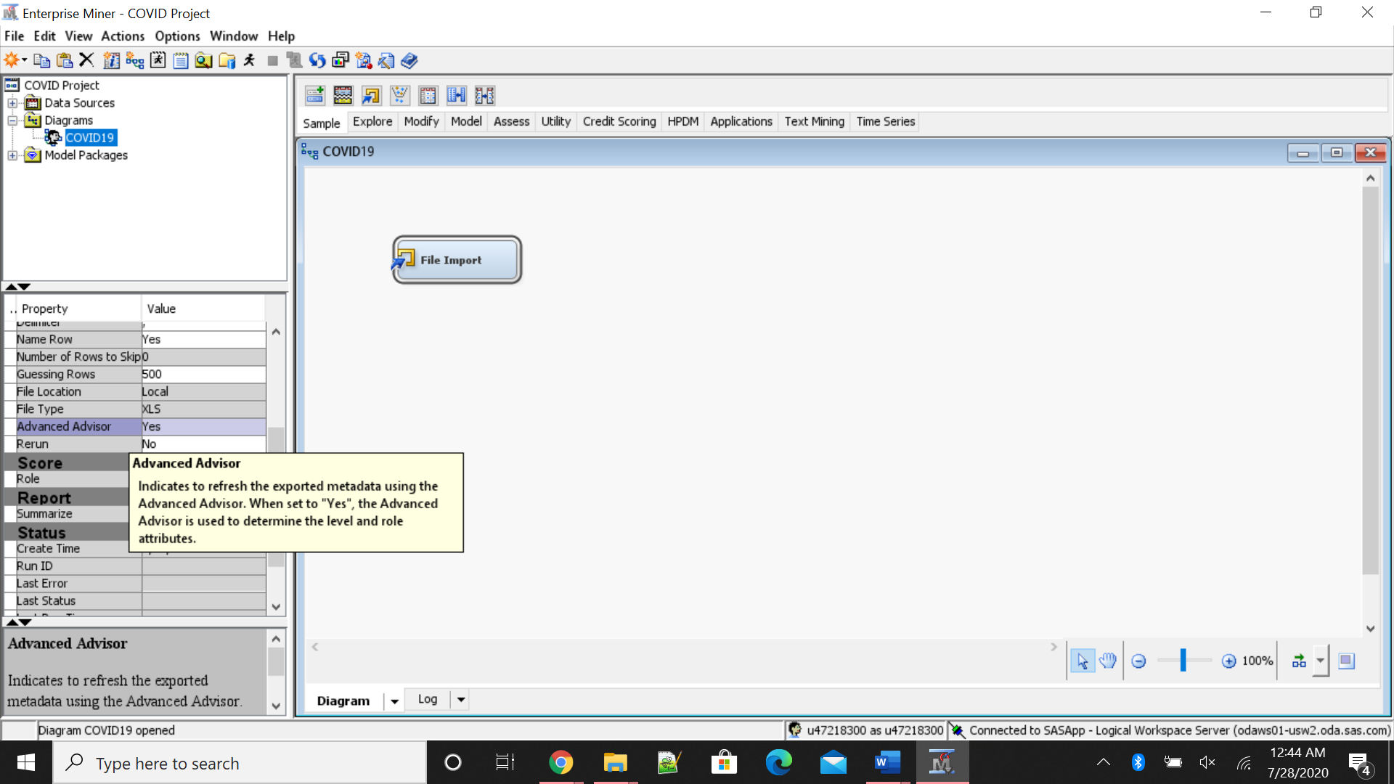

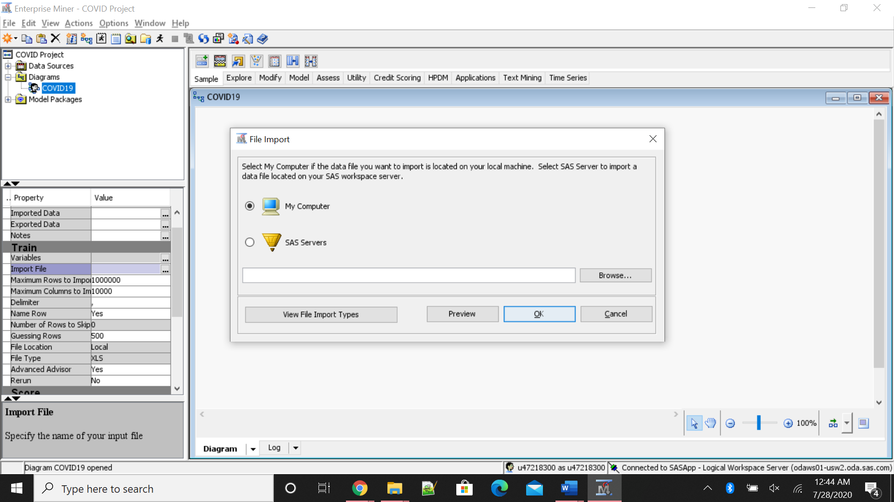

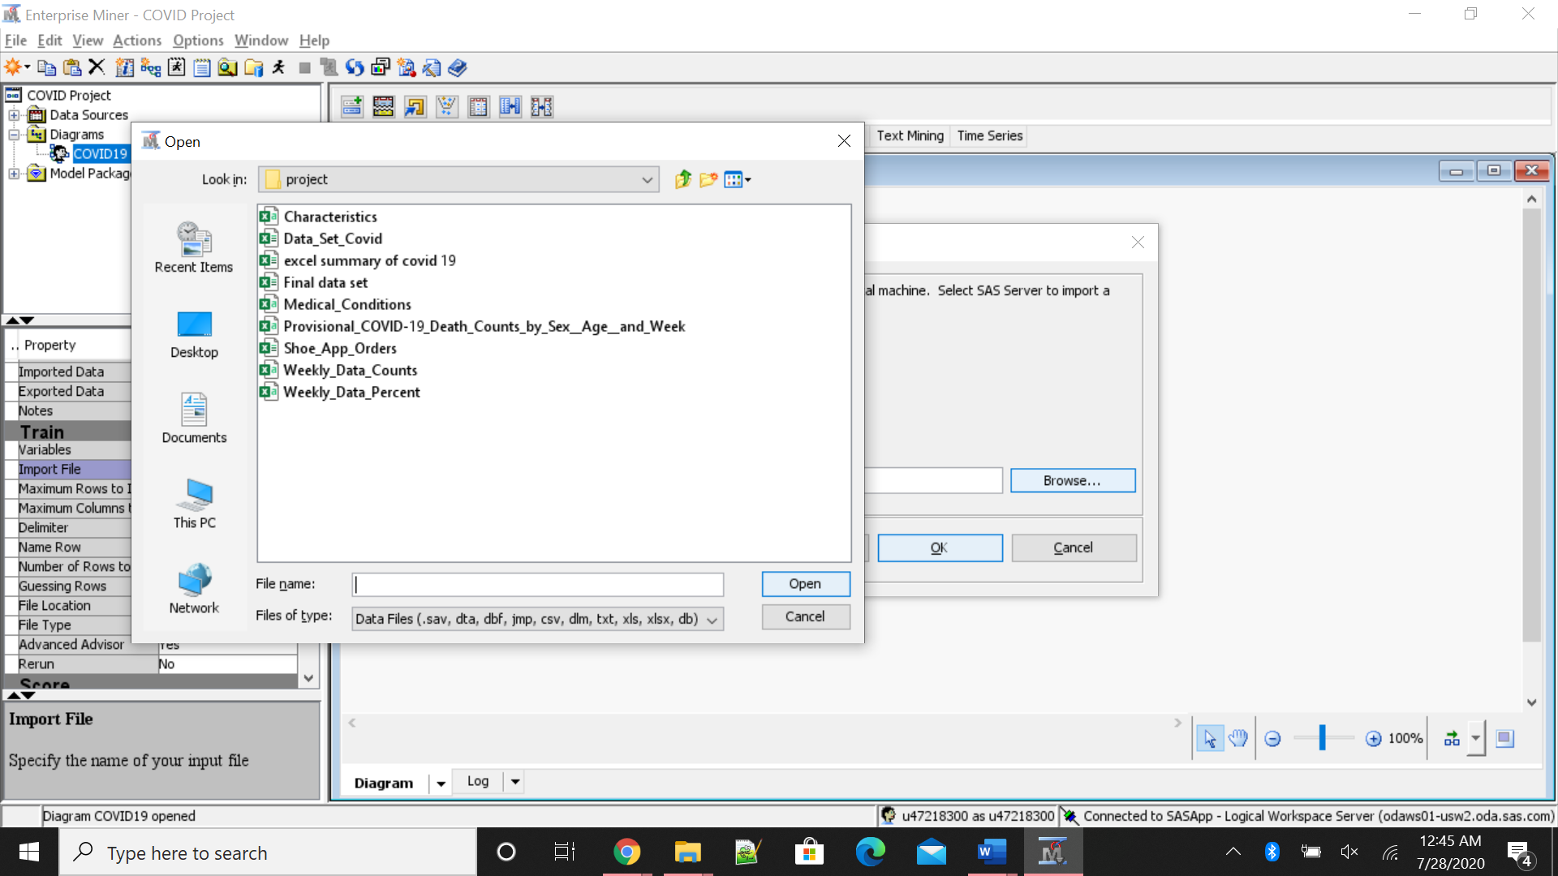

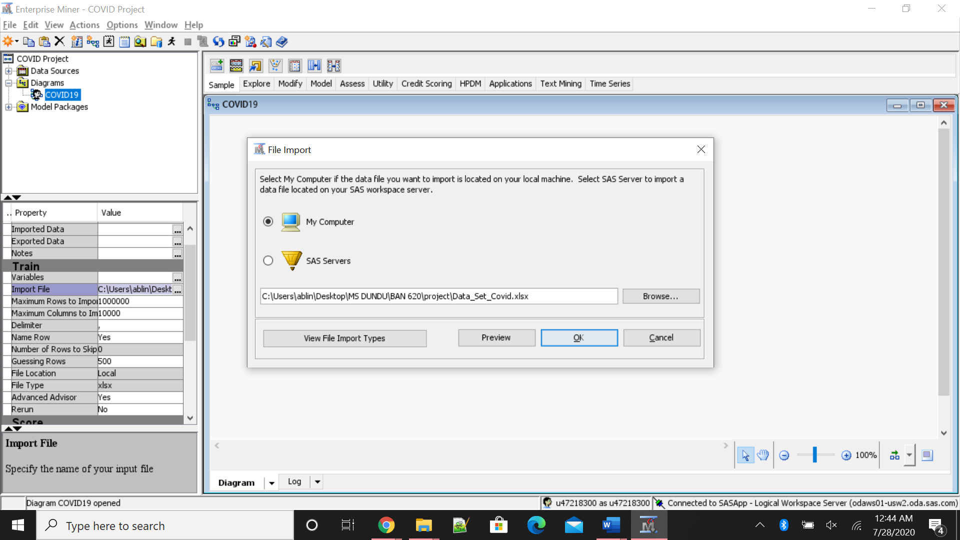

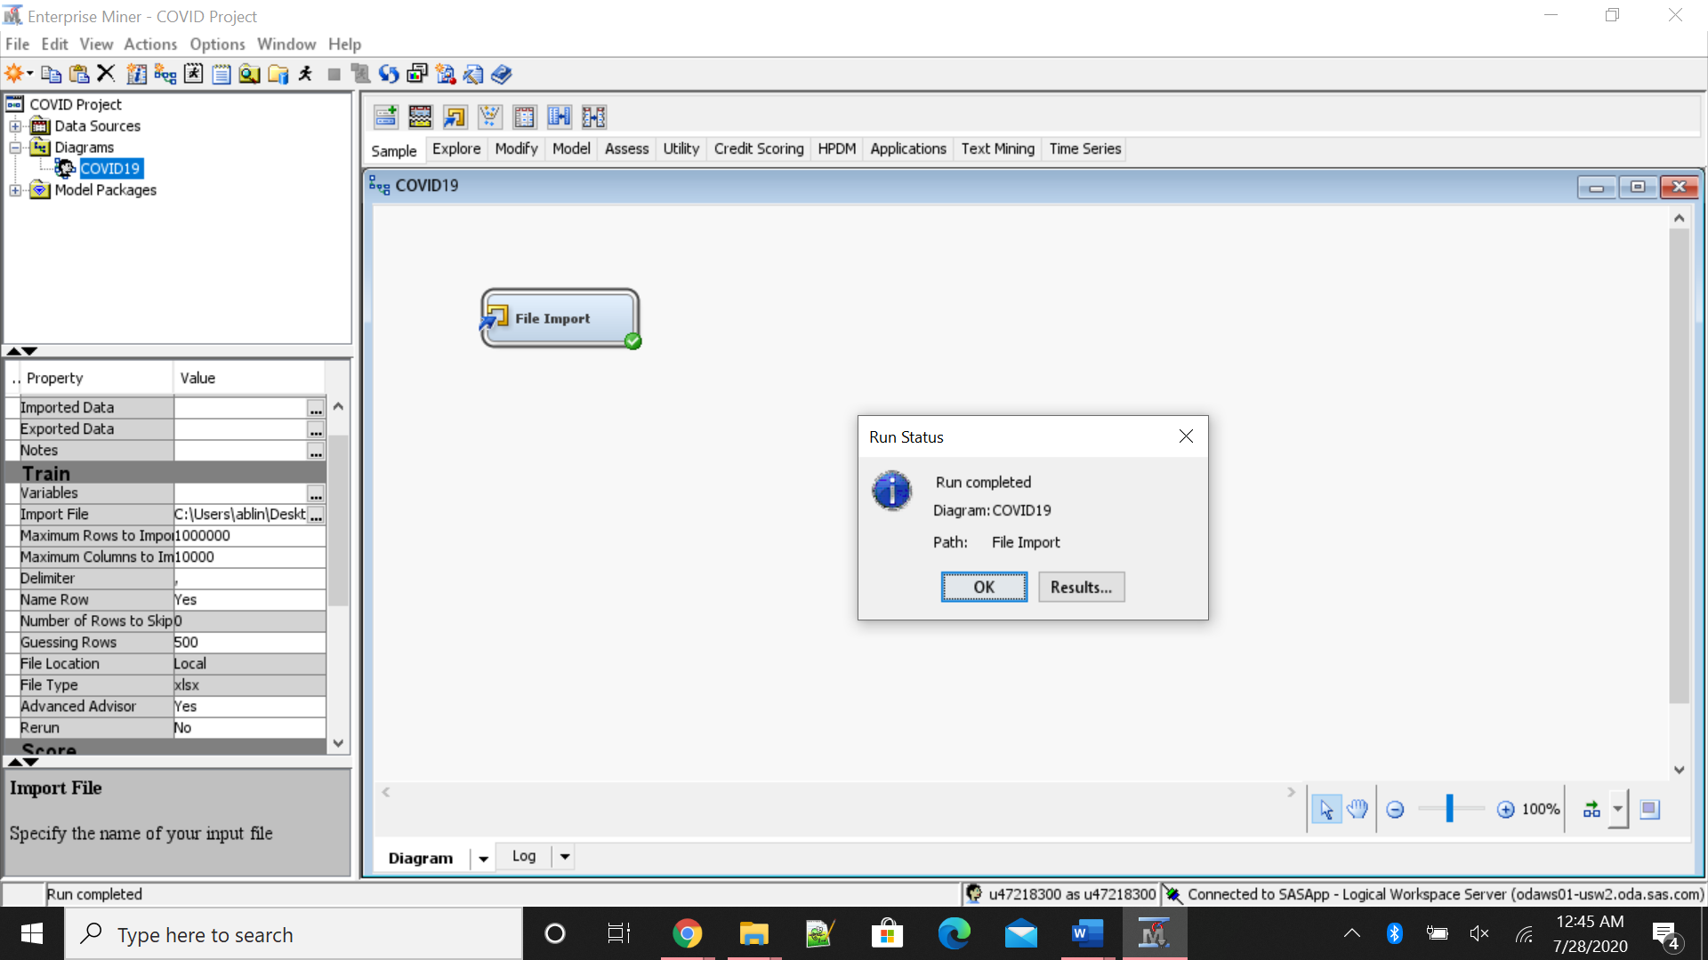

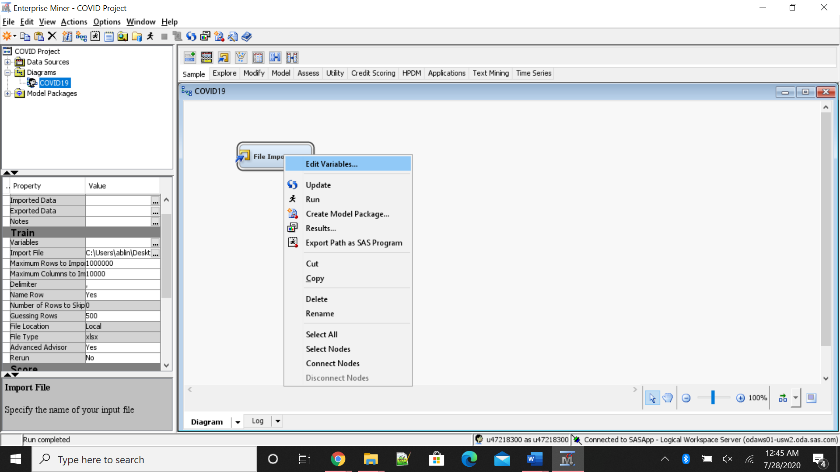

Once the simulation is successfully run, we have to edit variables, change all the variables from nominal level to interval level as time series analysis use only interval data, it is a must. Change all other variables except Week_end_date to target variable as we want to analyze all the variables.

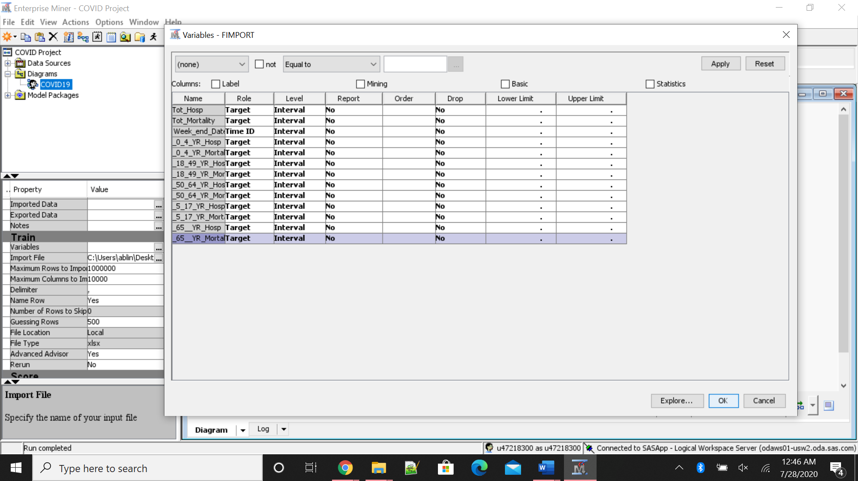

Once the file import and variable selection is complete, now we run the simulation to save the table in SAS servers.

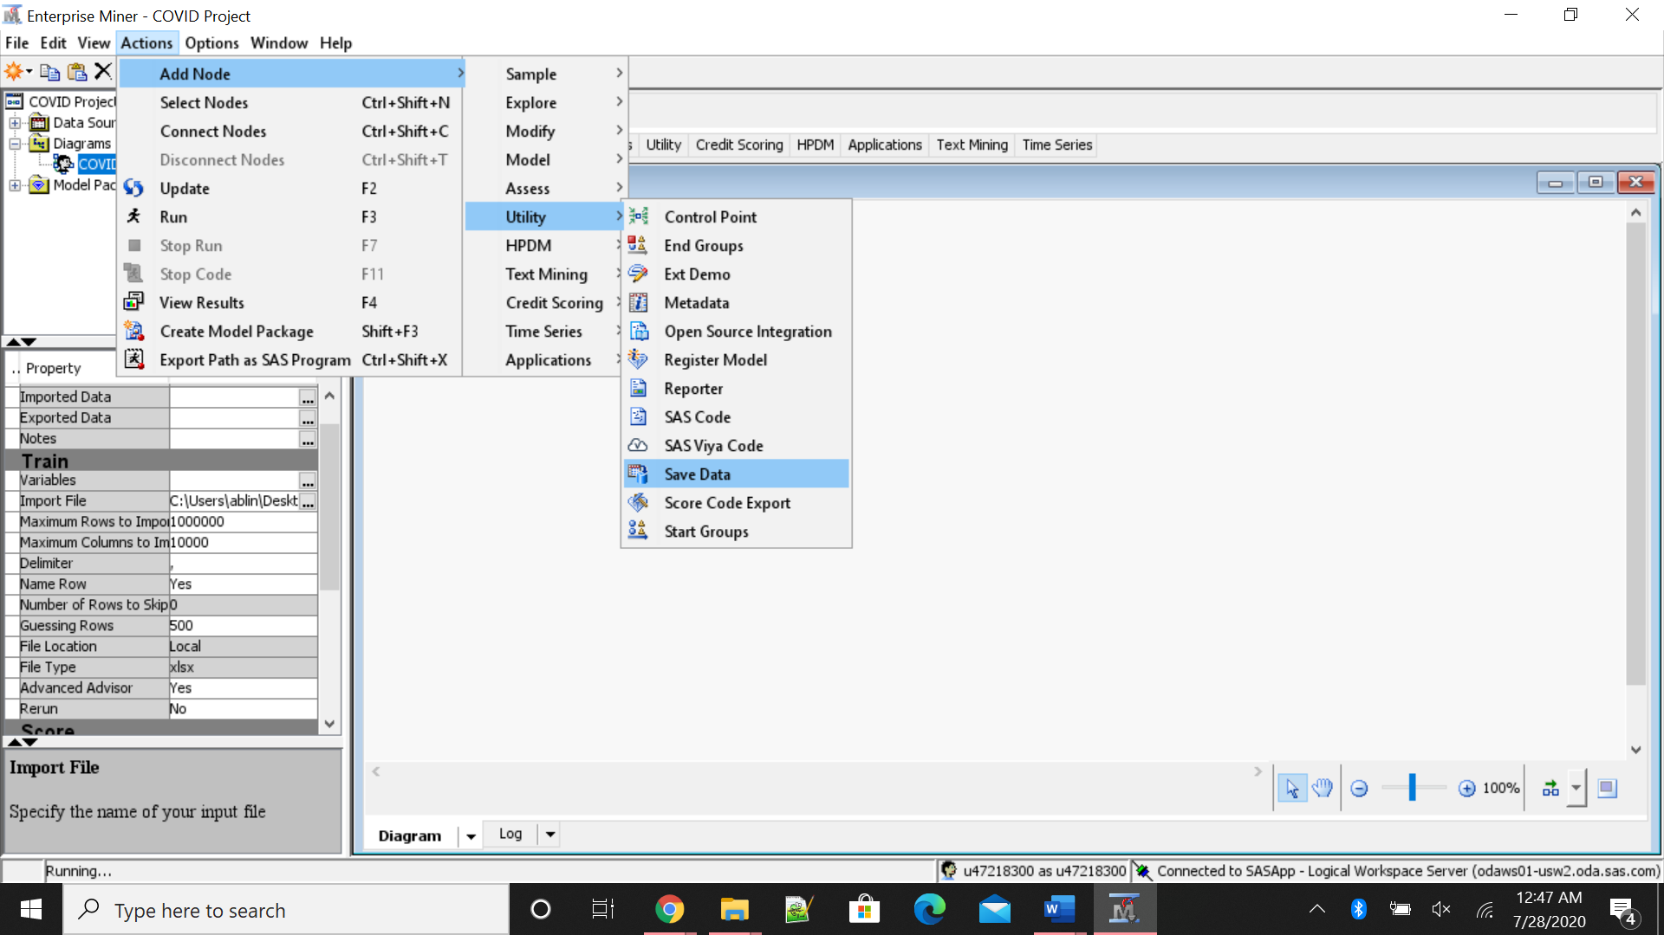

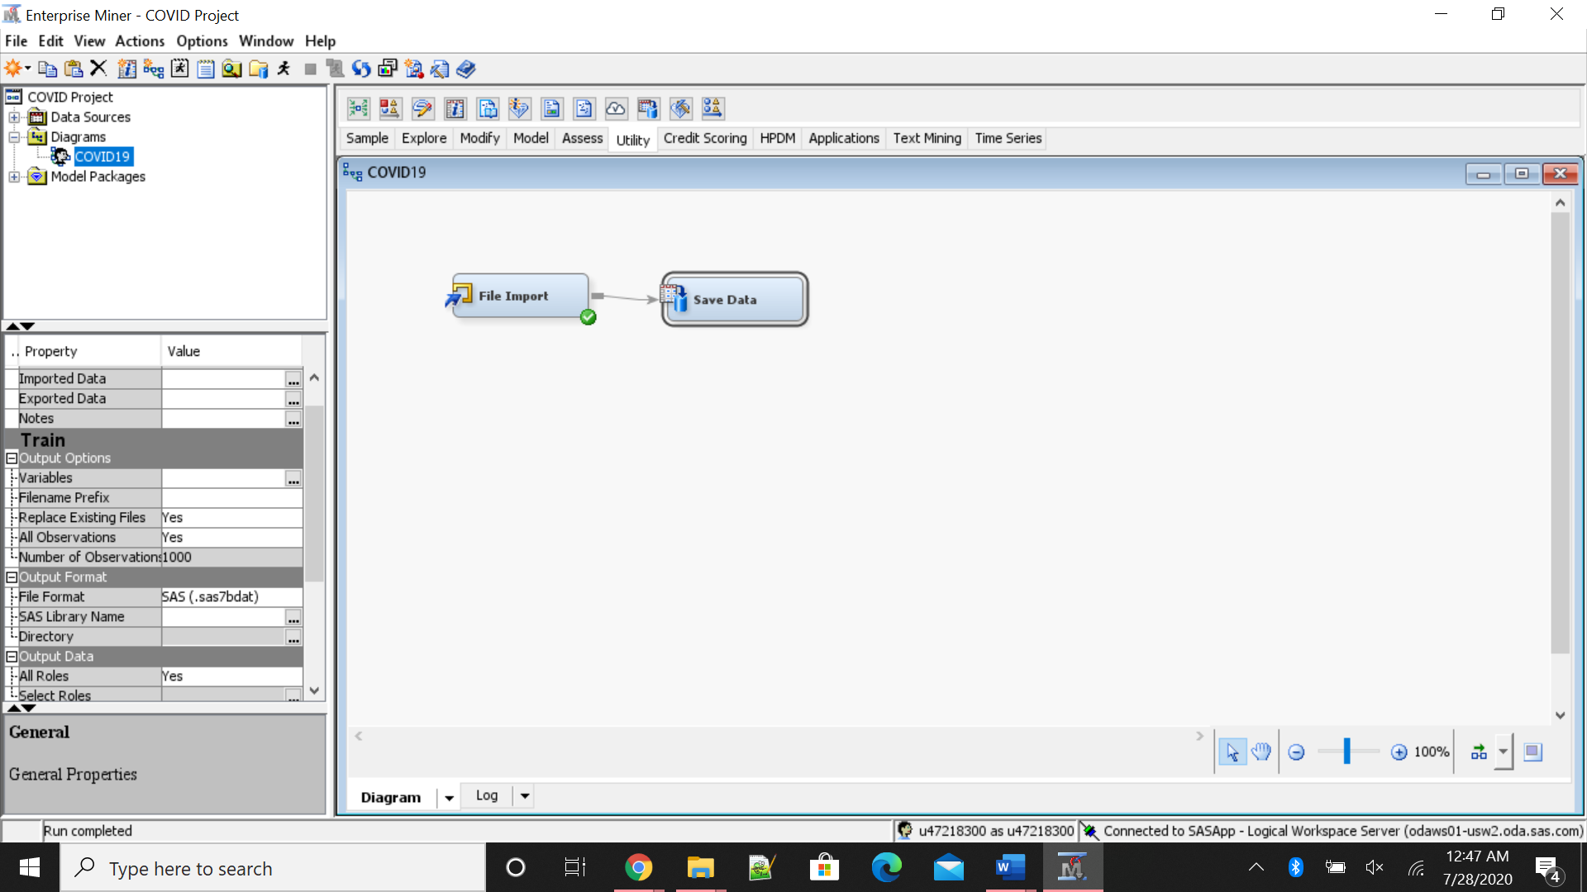

The next step after saving the file in SAS server is to create library to access the file that was uploaded/

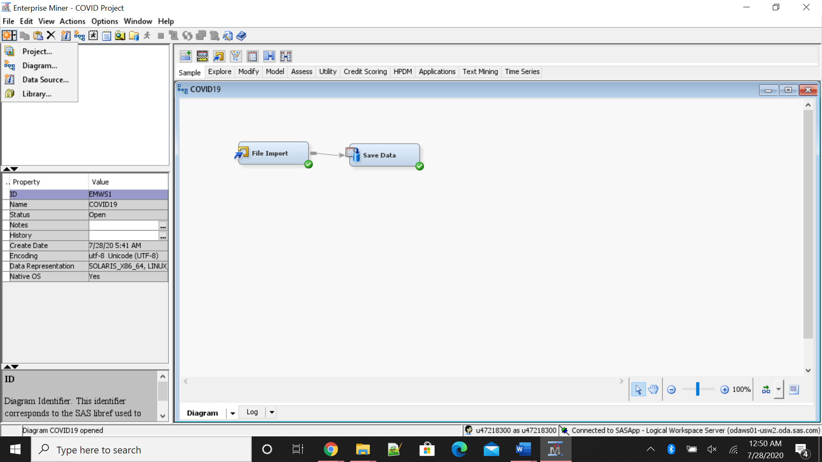

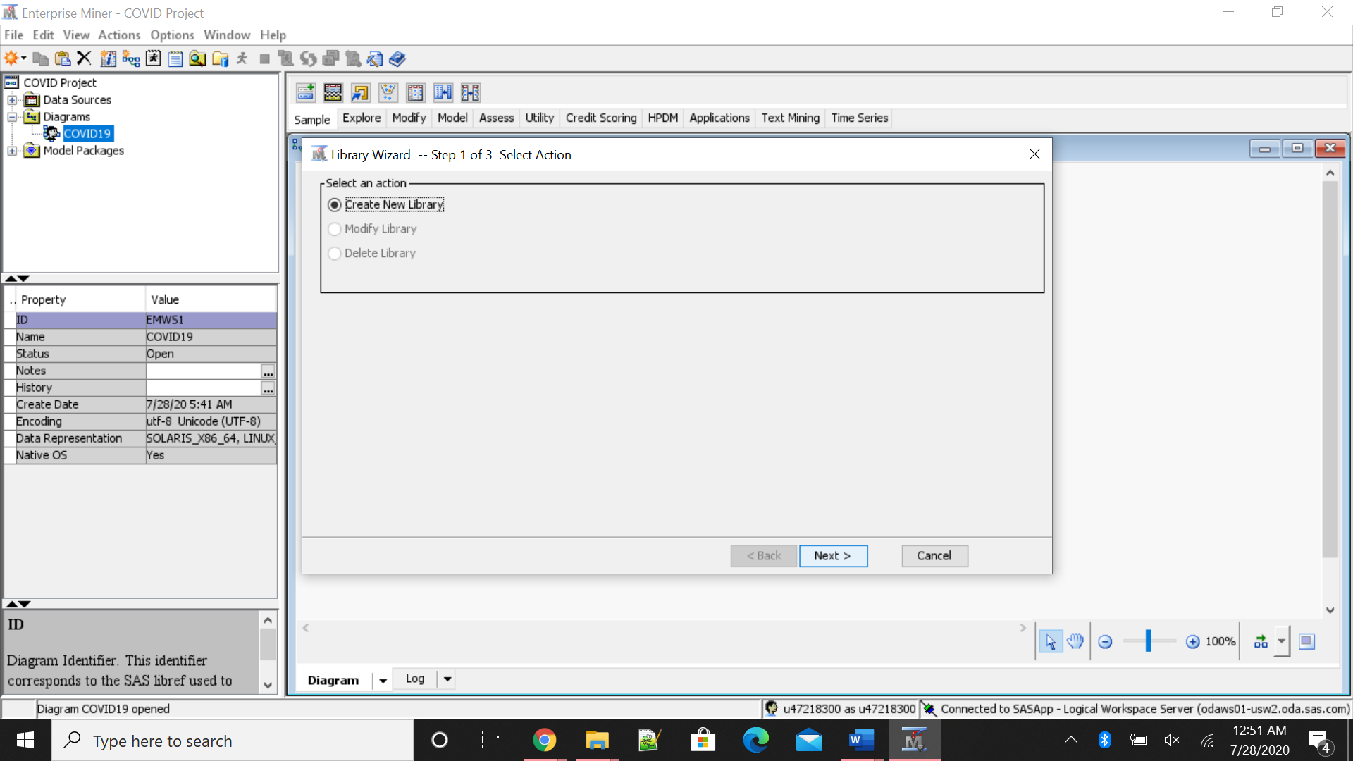

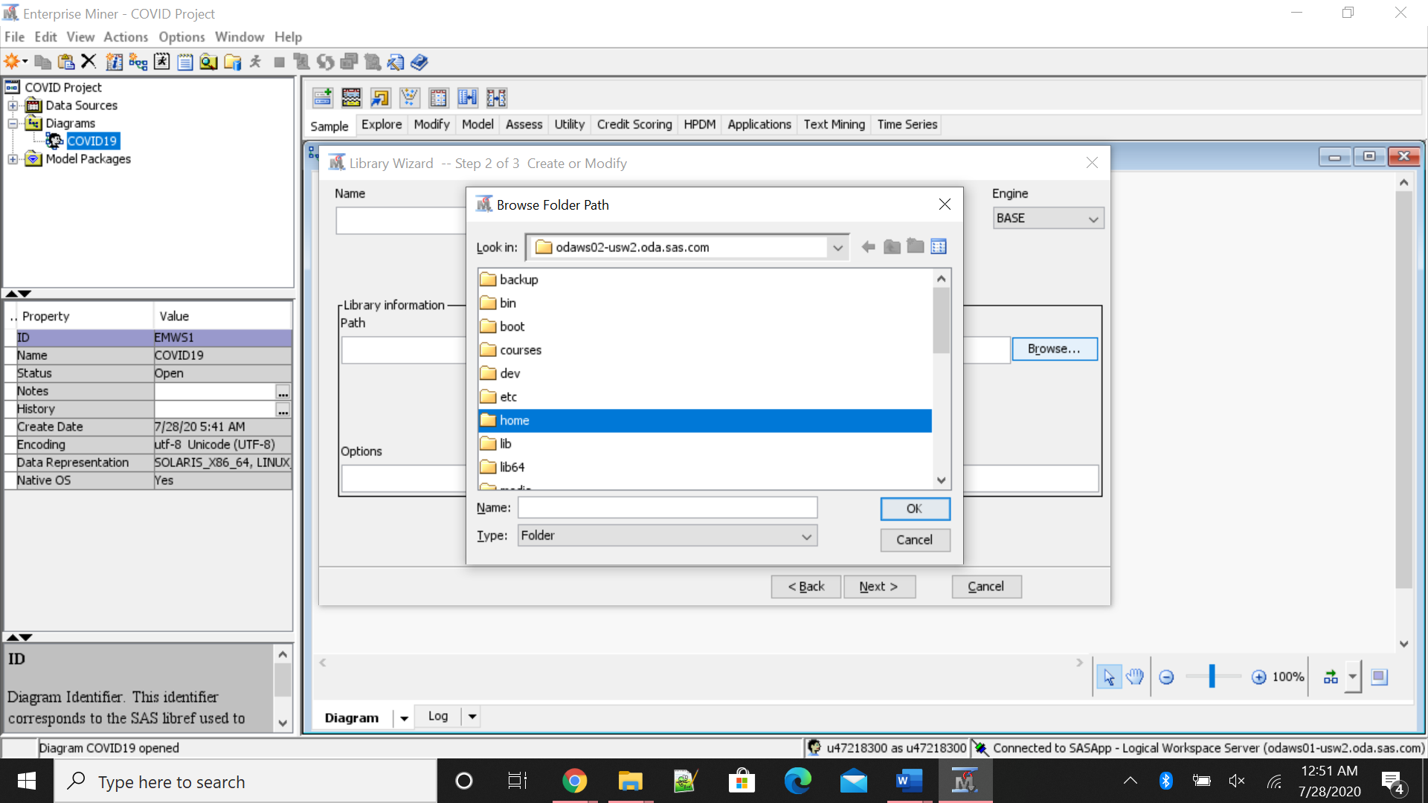

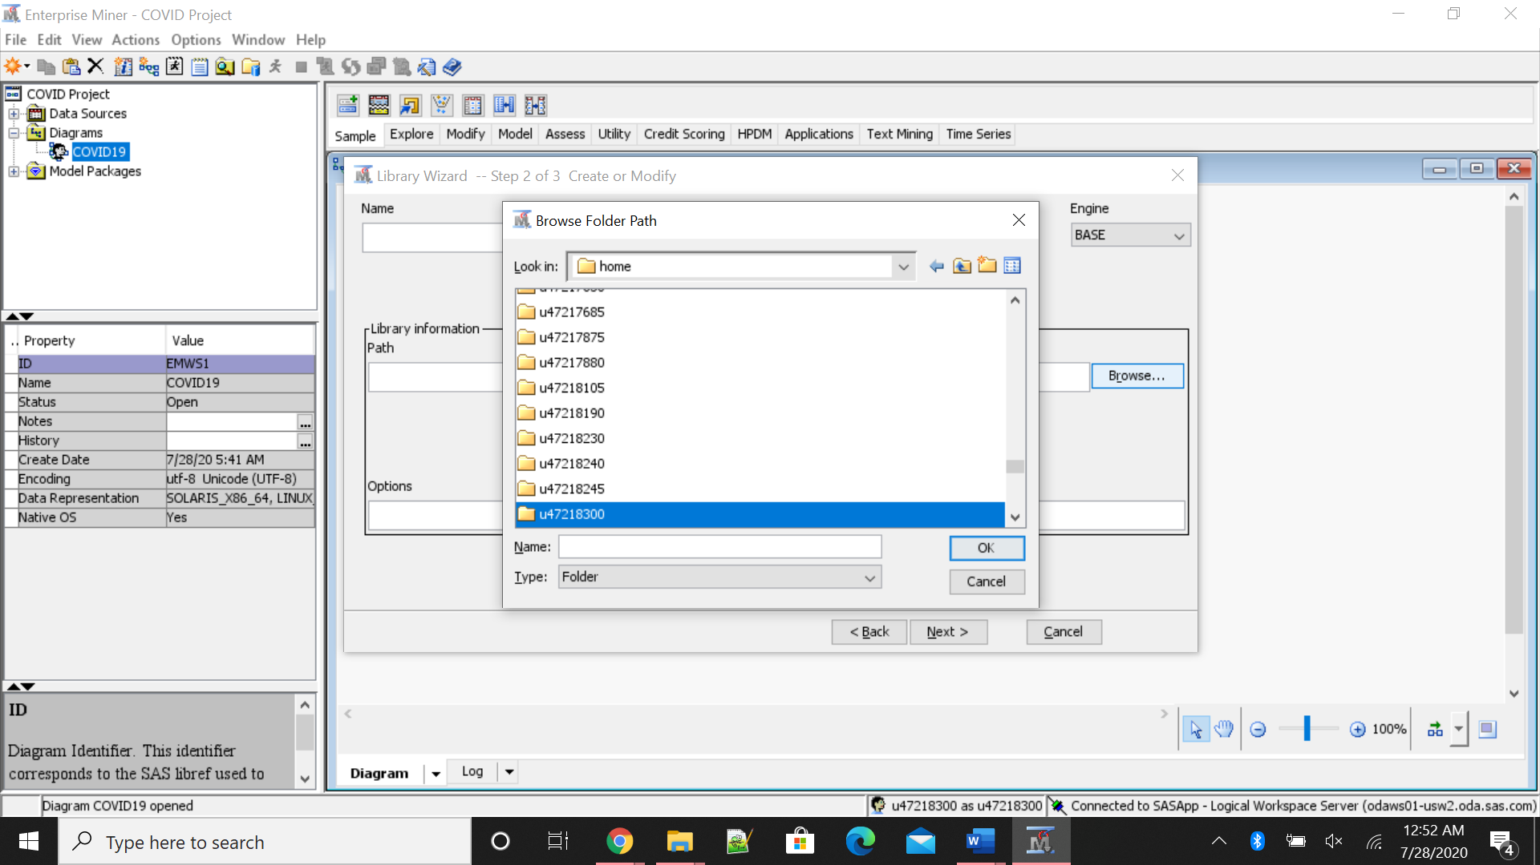

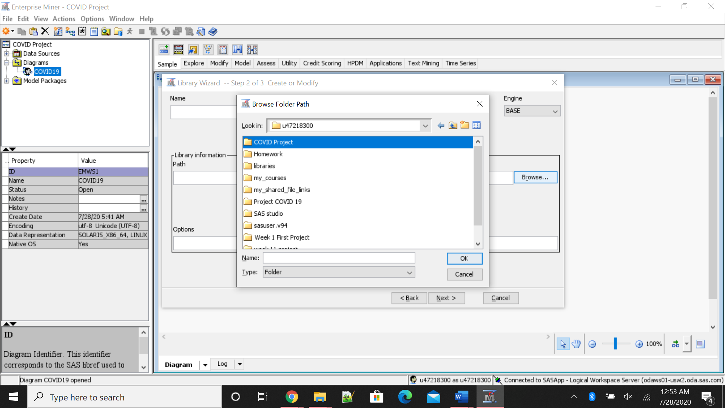

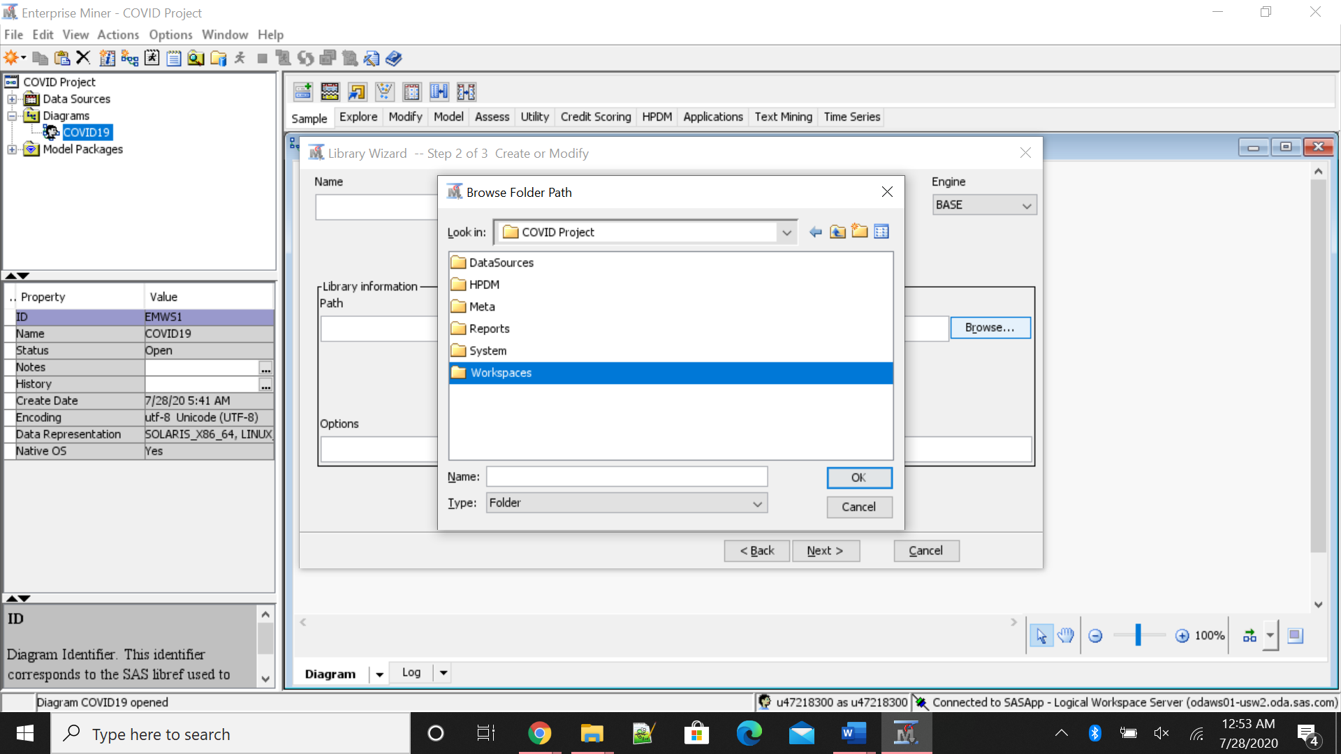

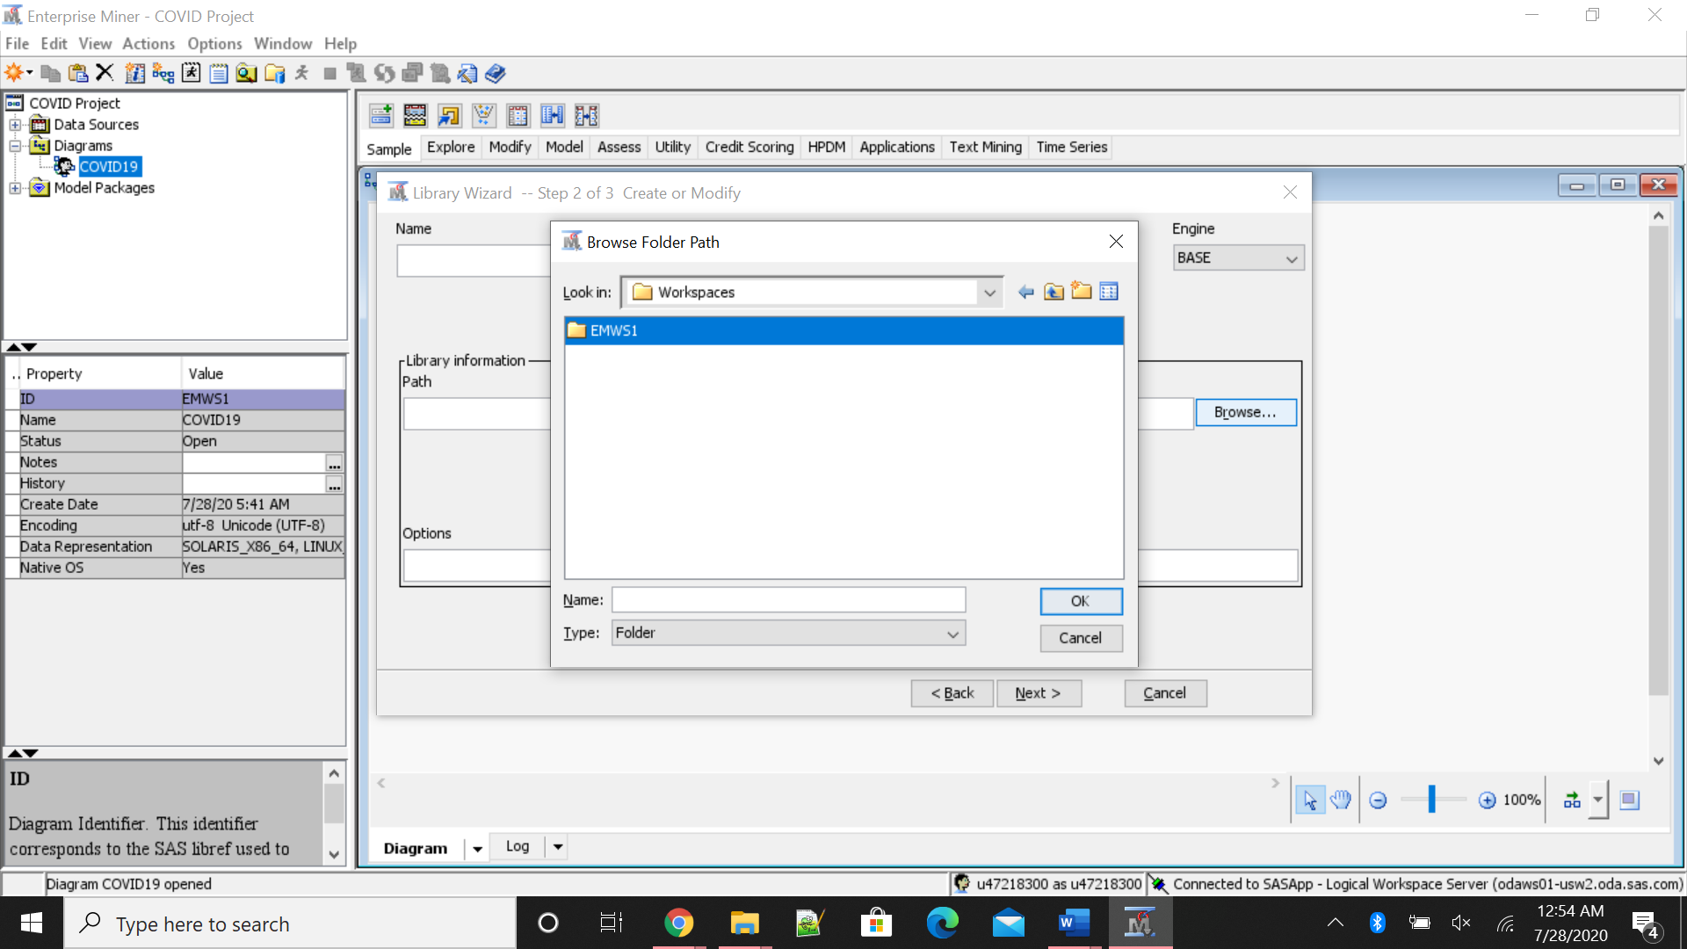

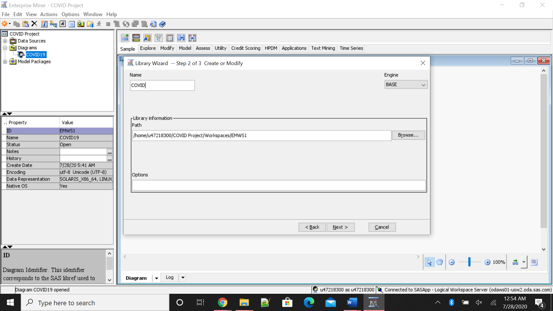

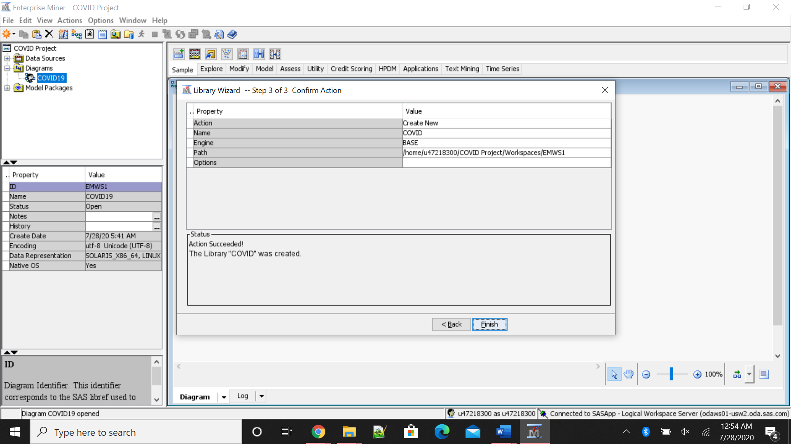

The access path for you to run this simulation will be present in your own UserID folder stored in SAS folder or one can obtain location from SAS studio.

The next step is to create a data source to read the table that was uploaded.

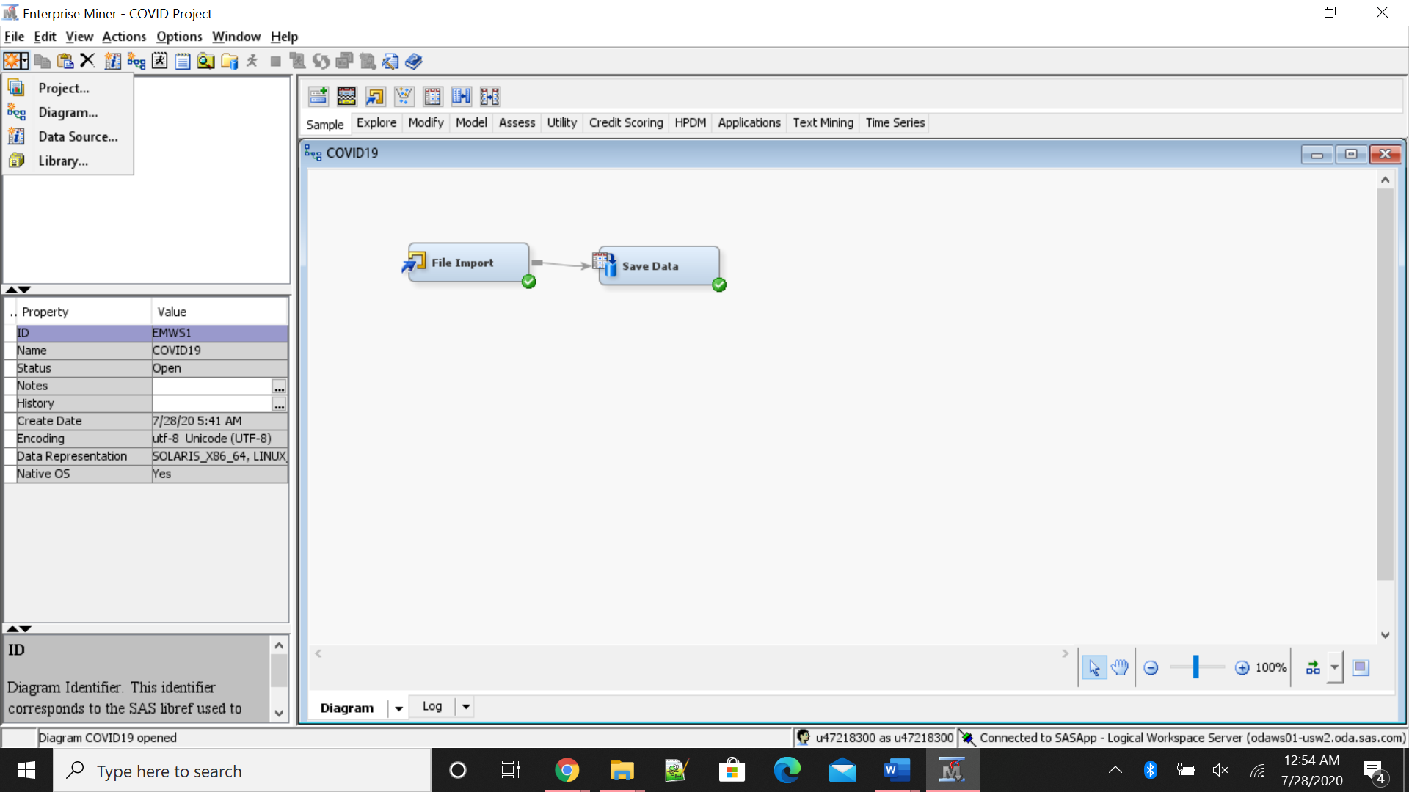

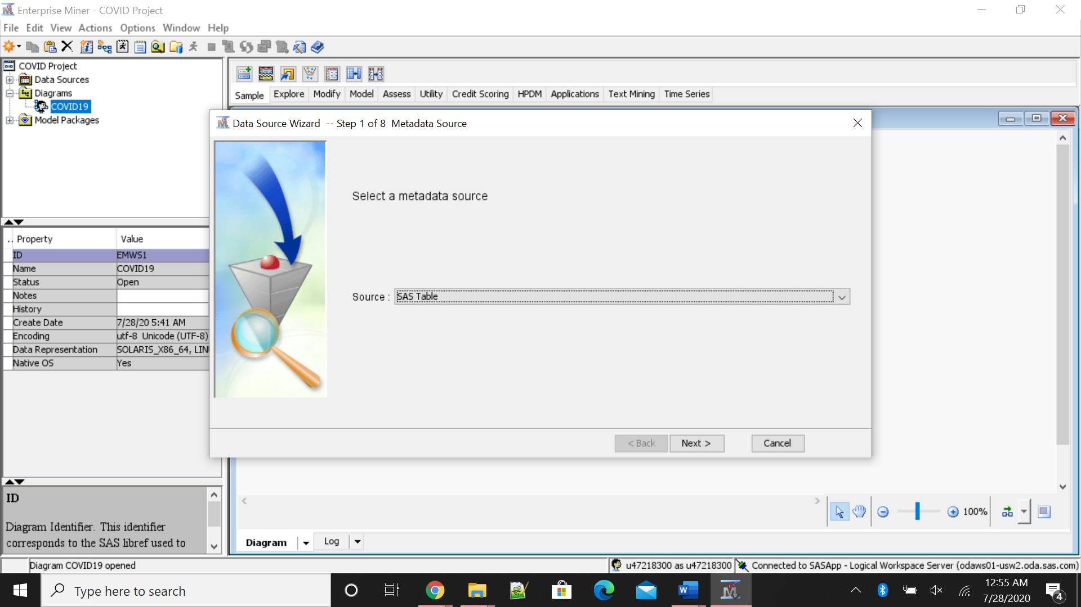

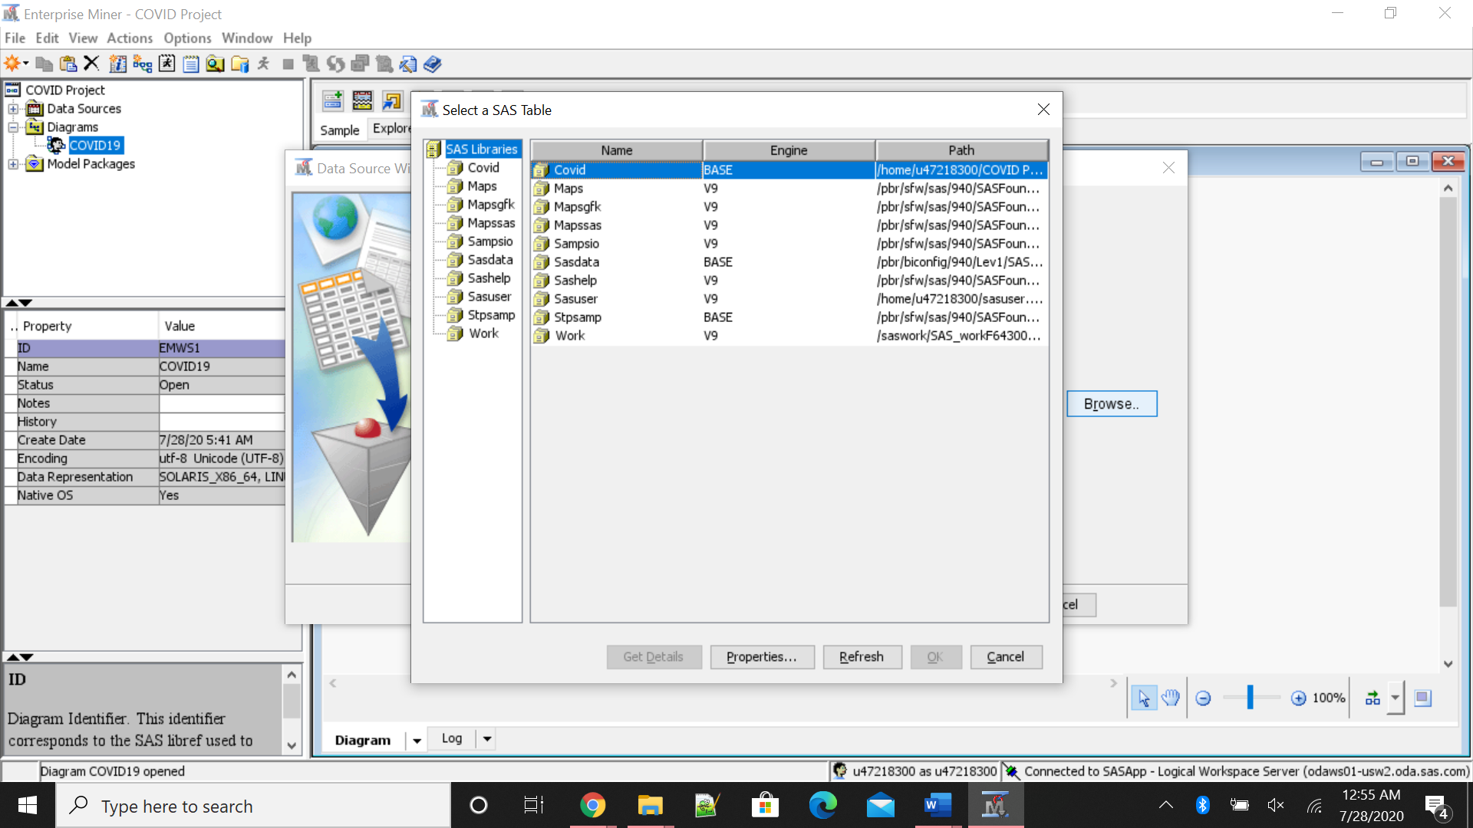

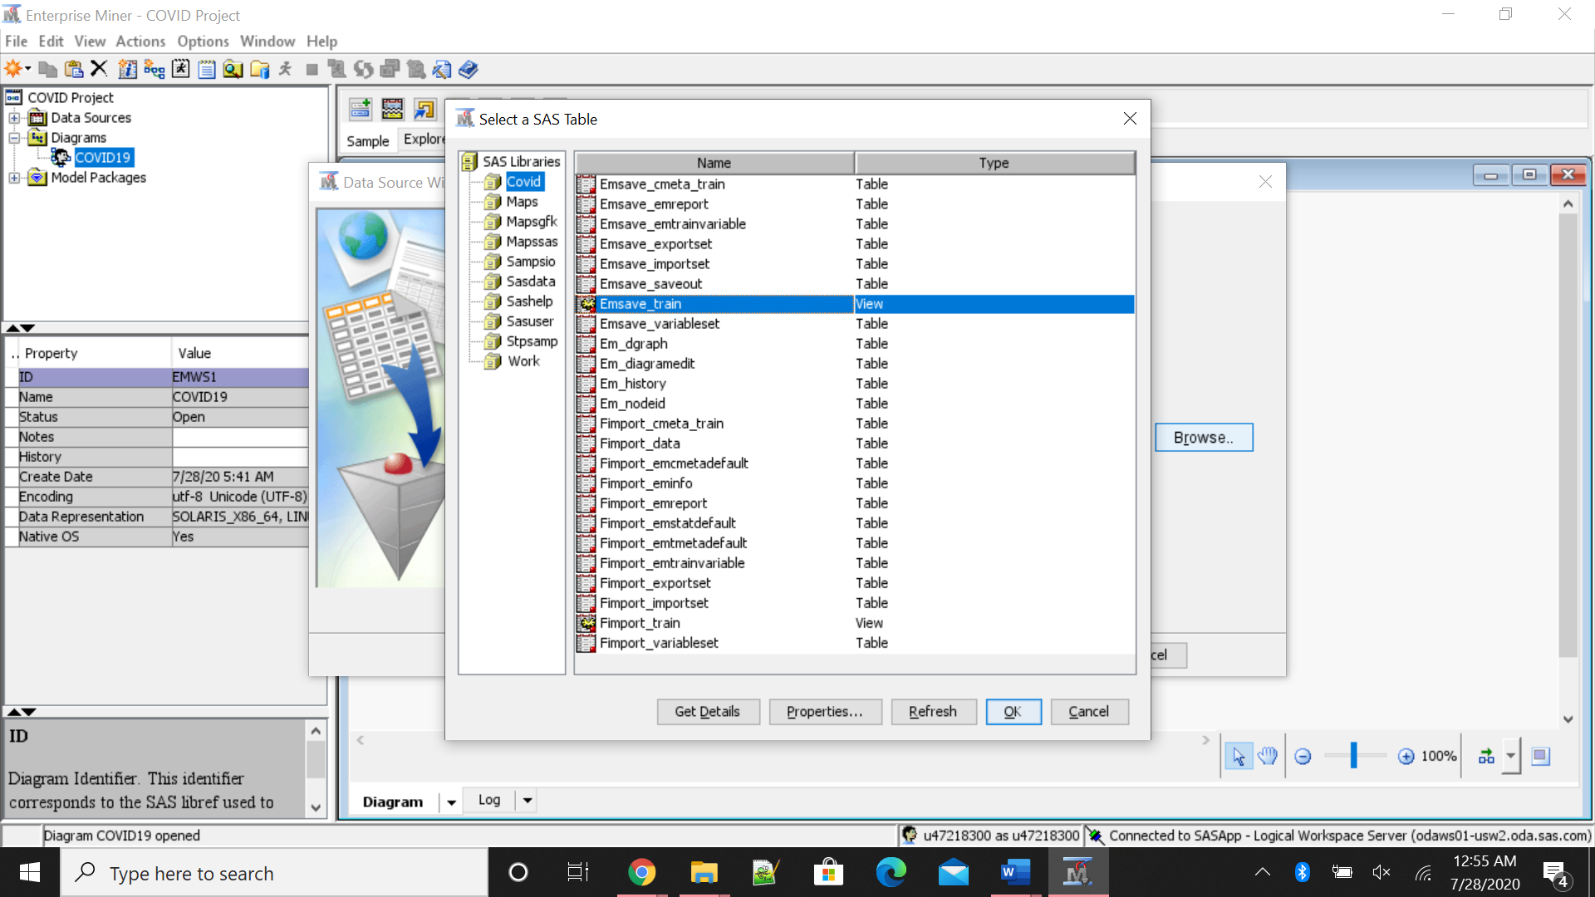

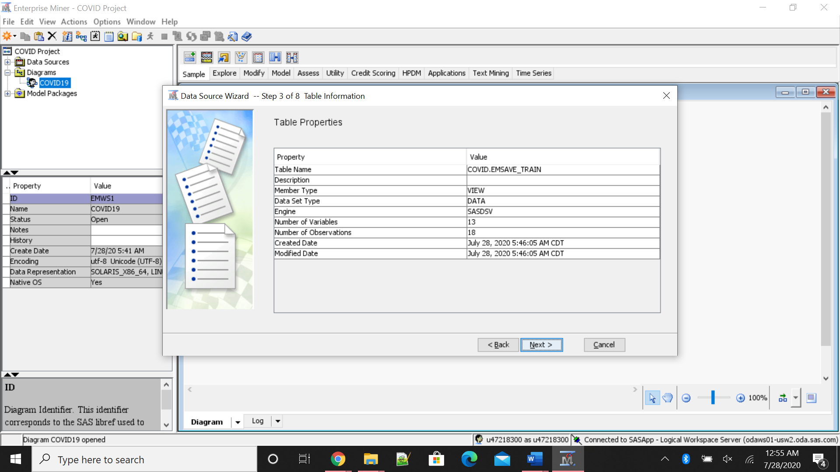

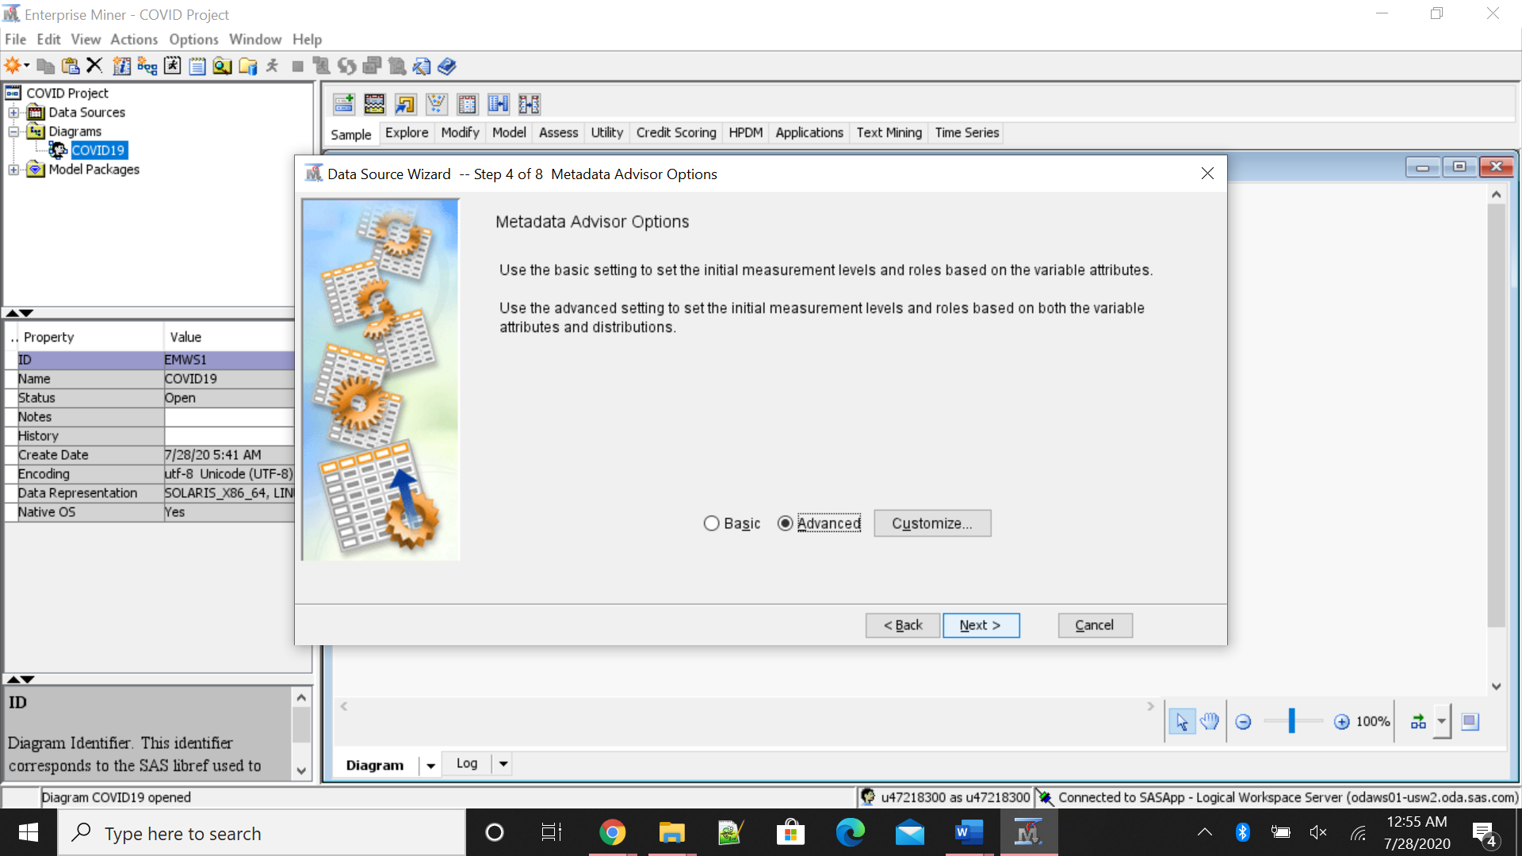

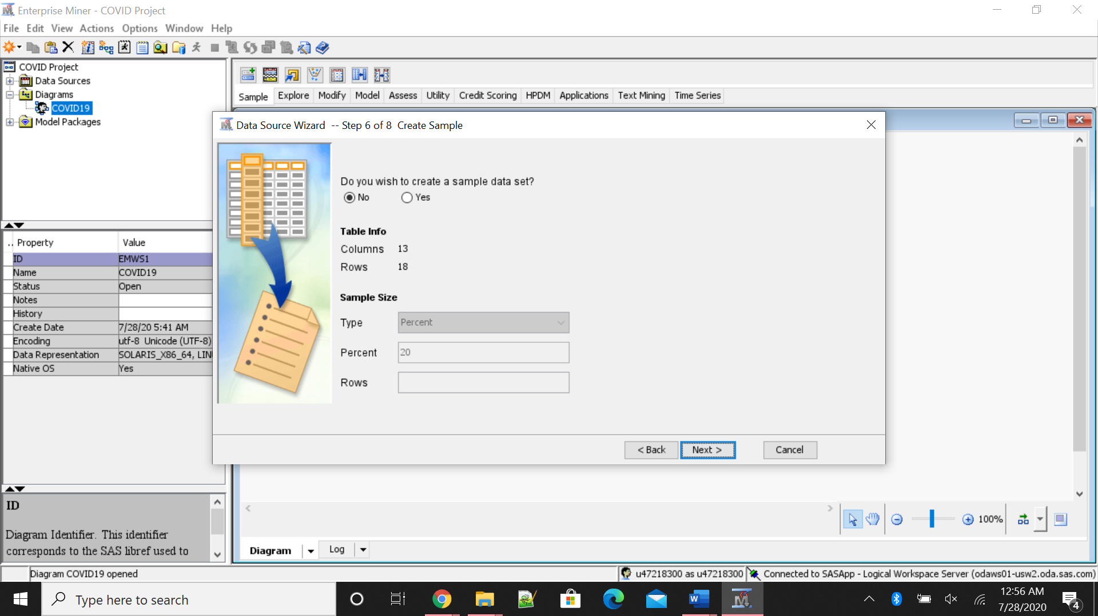

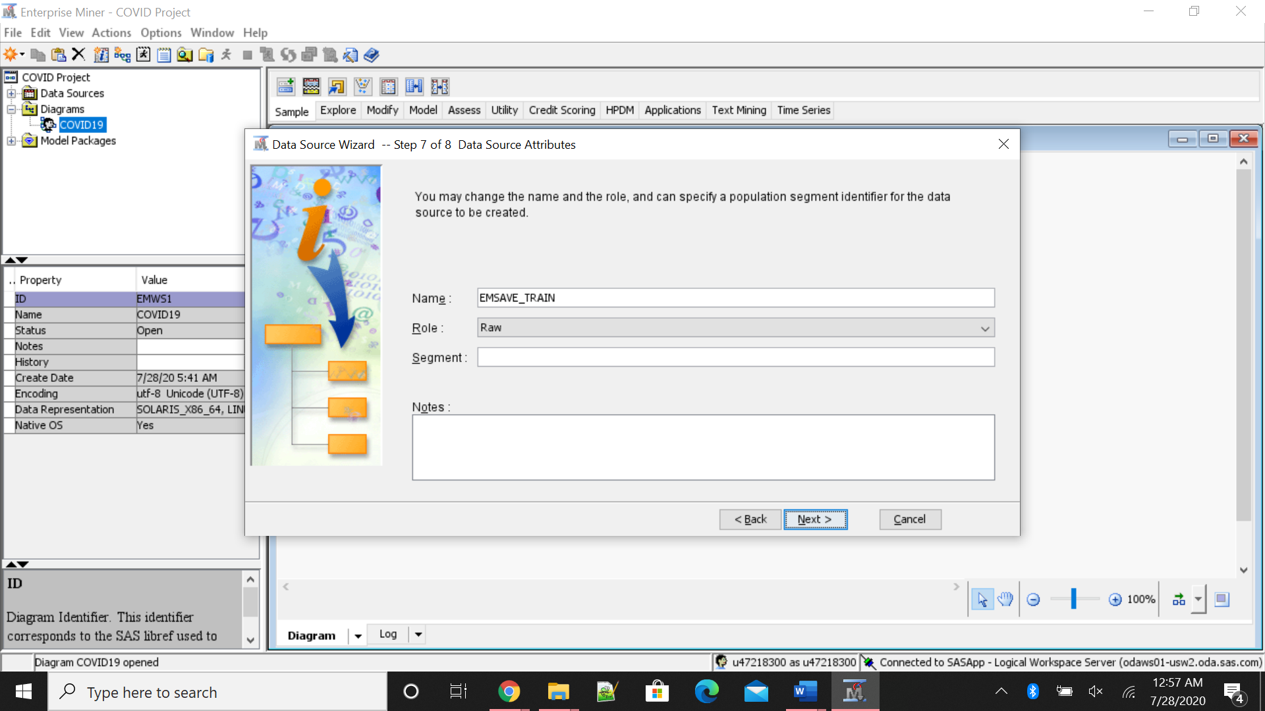

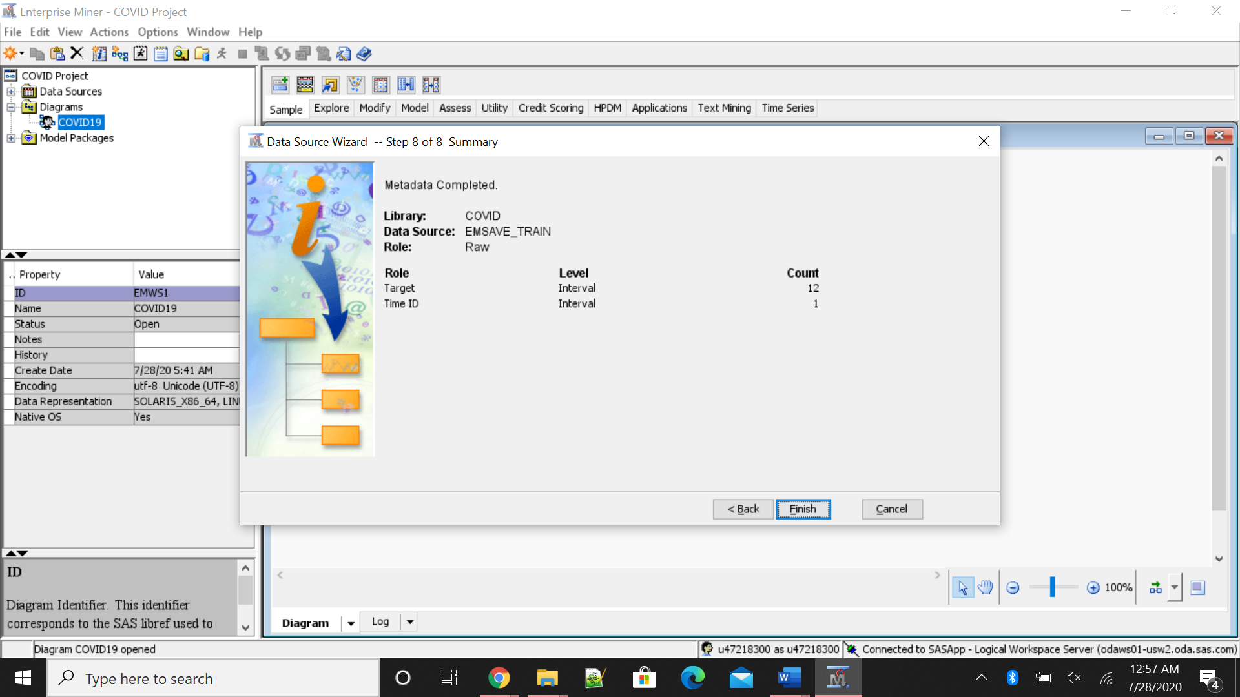

Analysis:

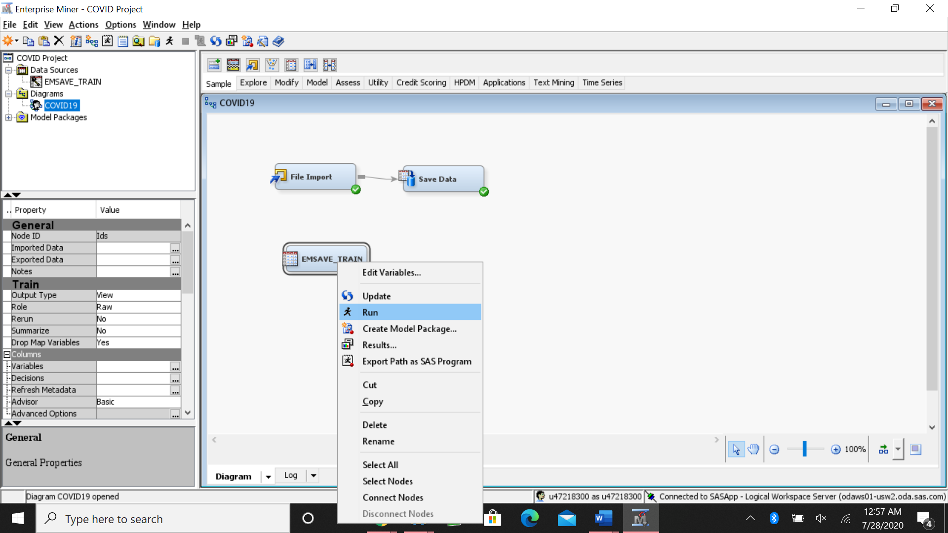

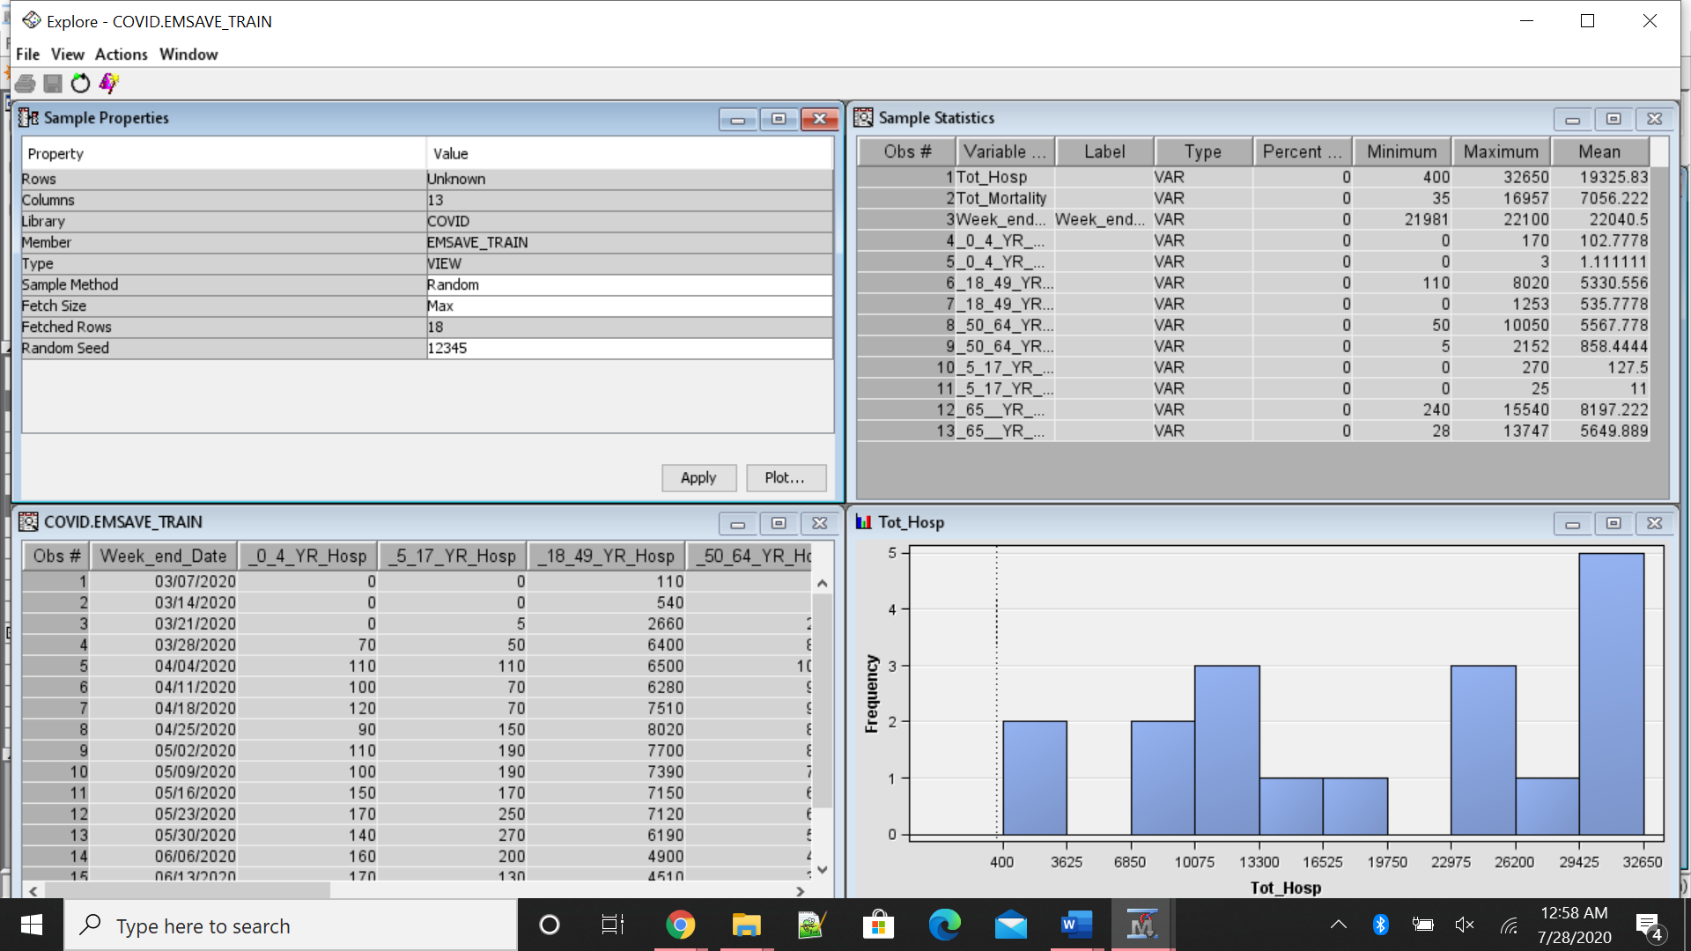

Now analyzing the data using Time series data. The first step is to use TS Data Preparation and then TS exponential smoothing to forecast data.

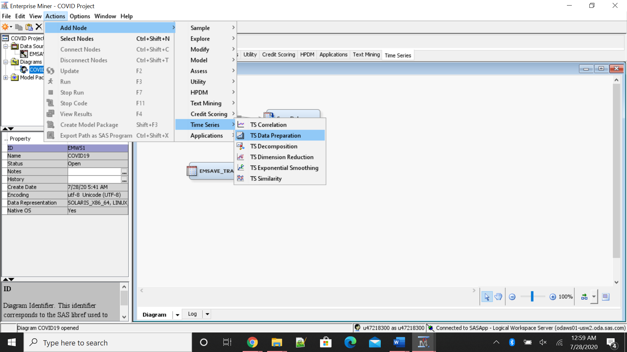

To successfully run the simulation, in TS Data Preparation properties, we have to change the interval from automatic to week, which is highlighted in the following image.

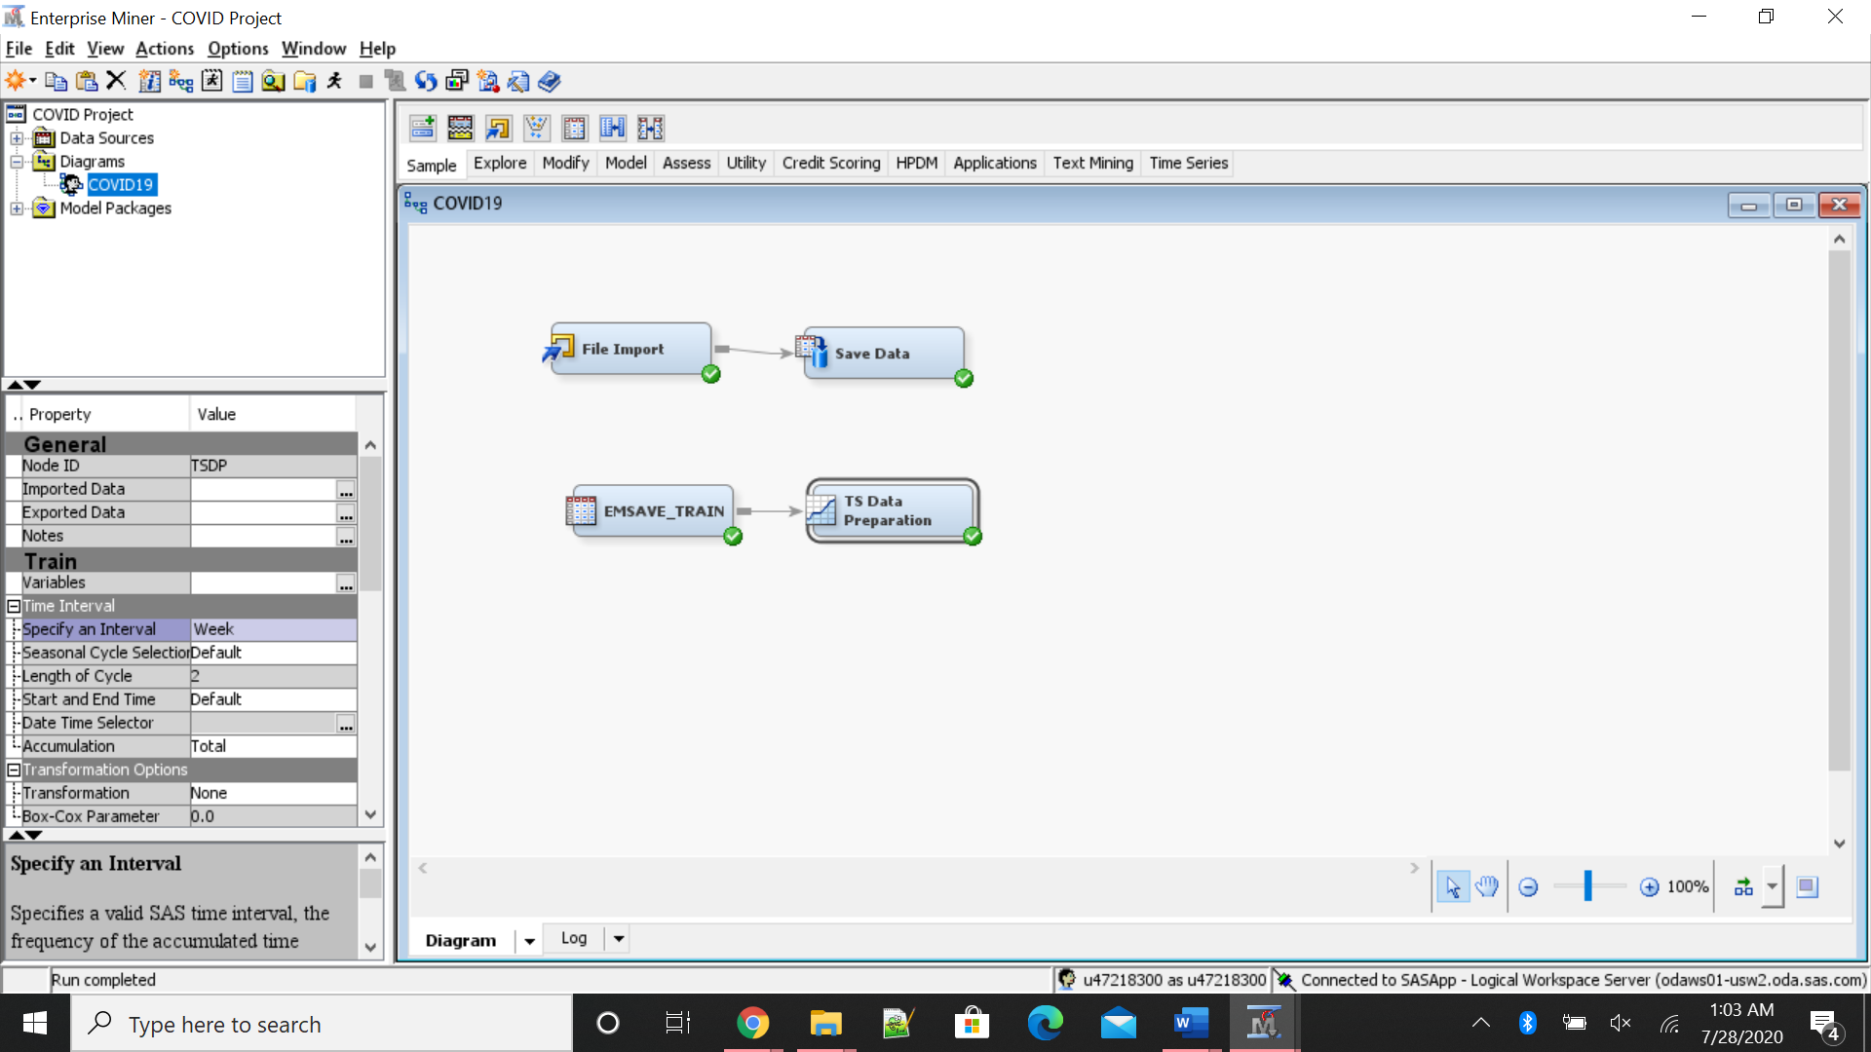

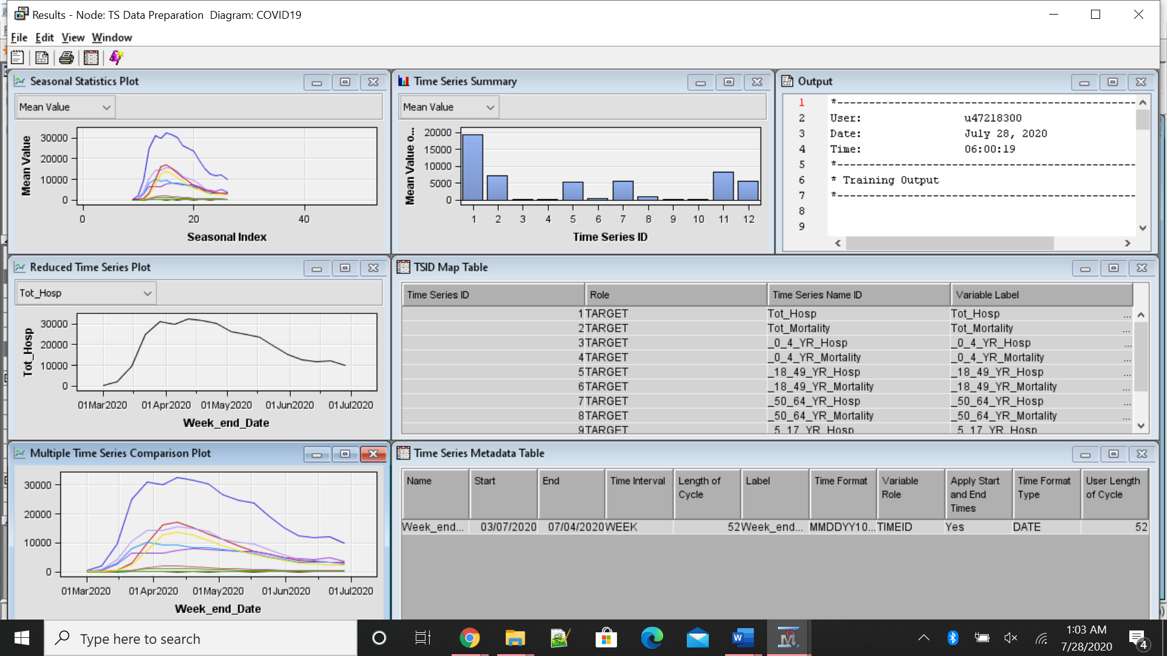

The following picture gives the visual representation of cases age wise by week .

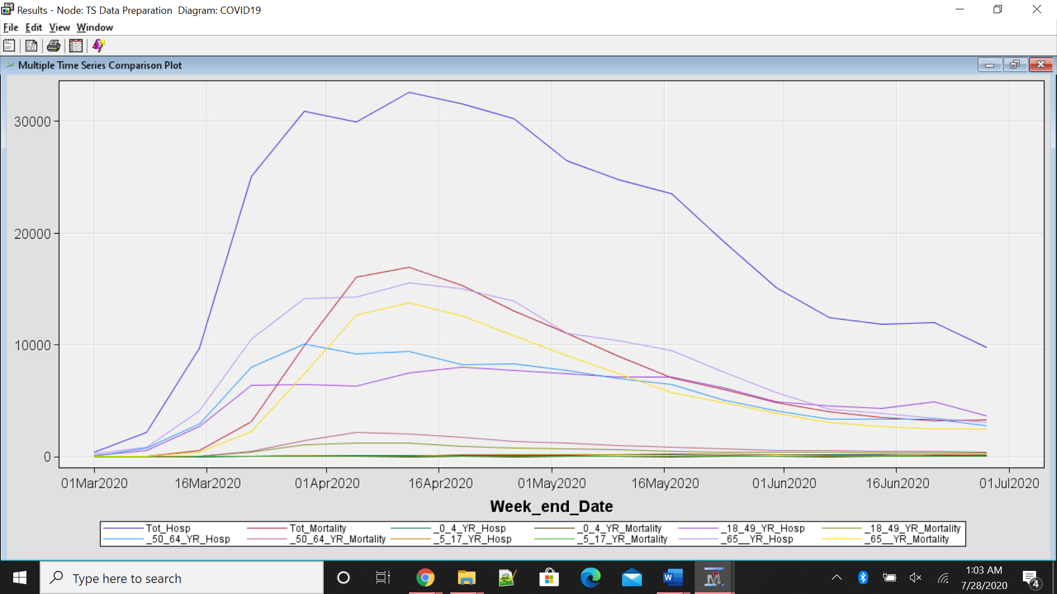

The following image shows the comparison of hospitalization and mortality among 0-4 years.

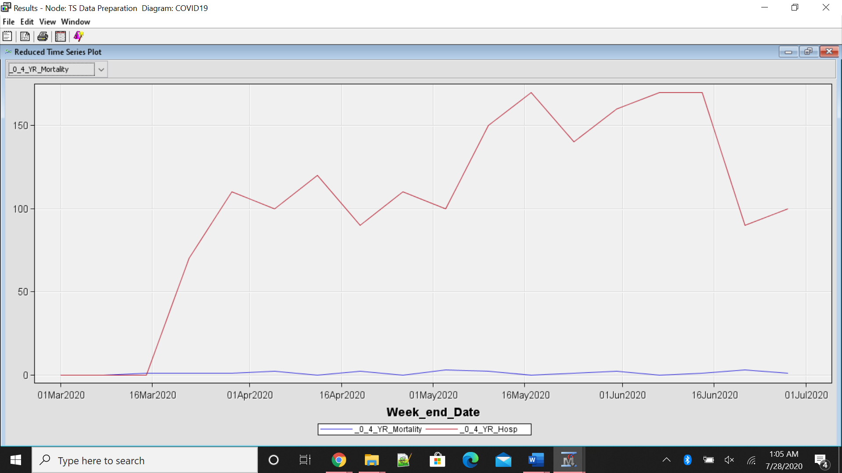

The following image shows the comparison of hospitalization and mortality among 5-17 years.

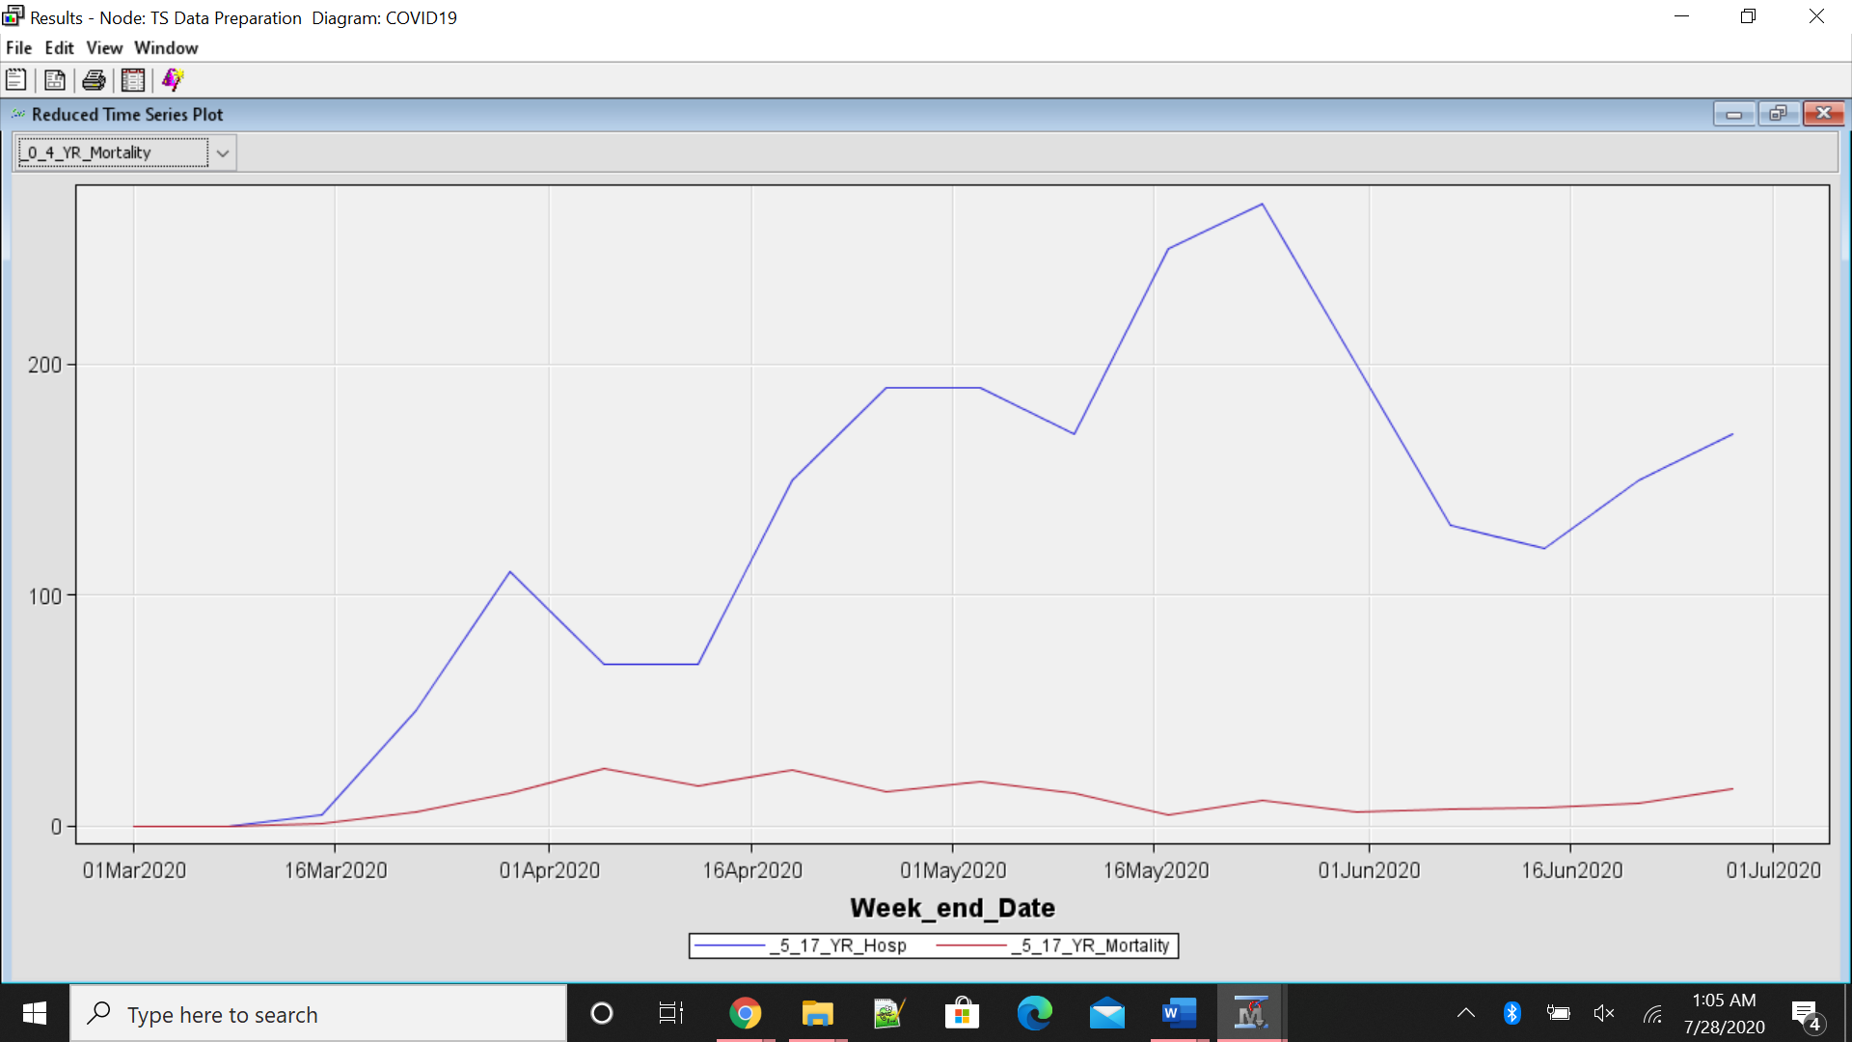

The following image shows the comparison of hospitalization and mortality among 18-49 years.

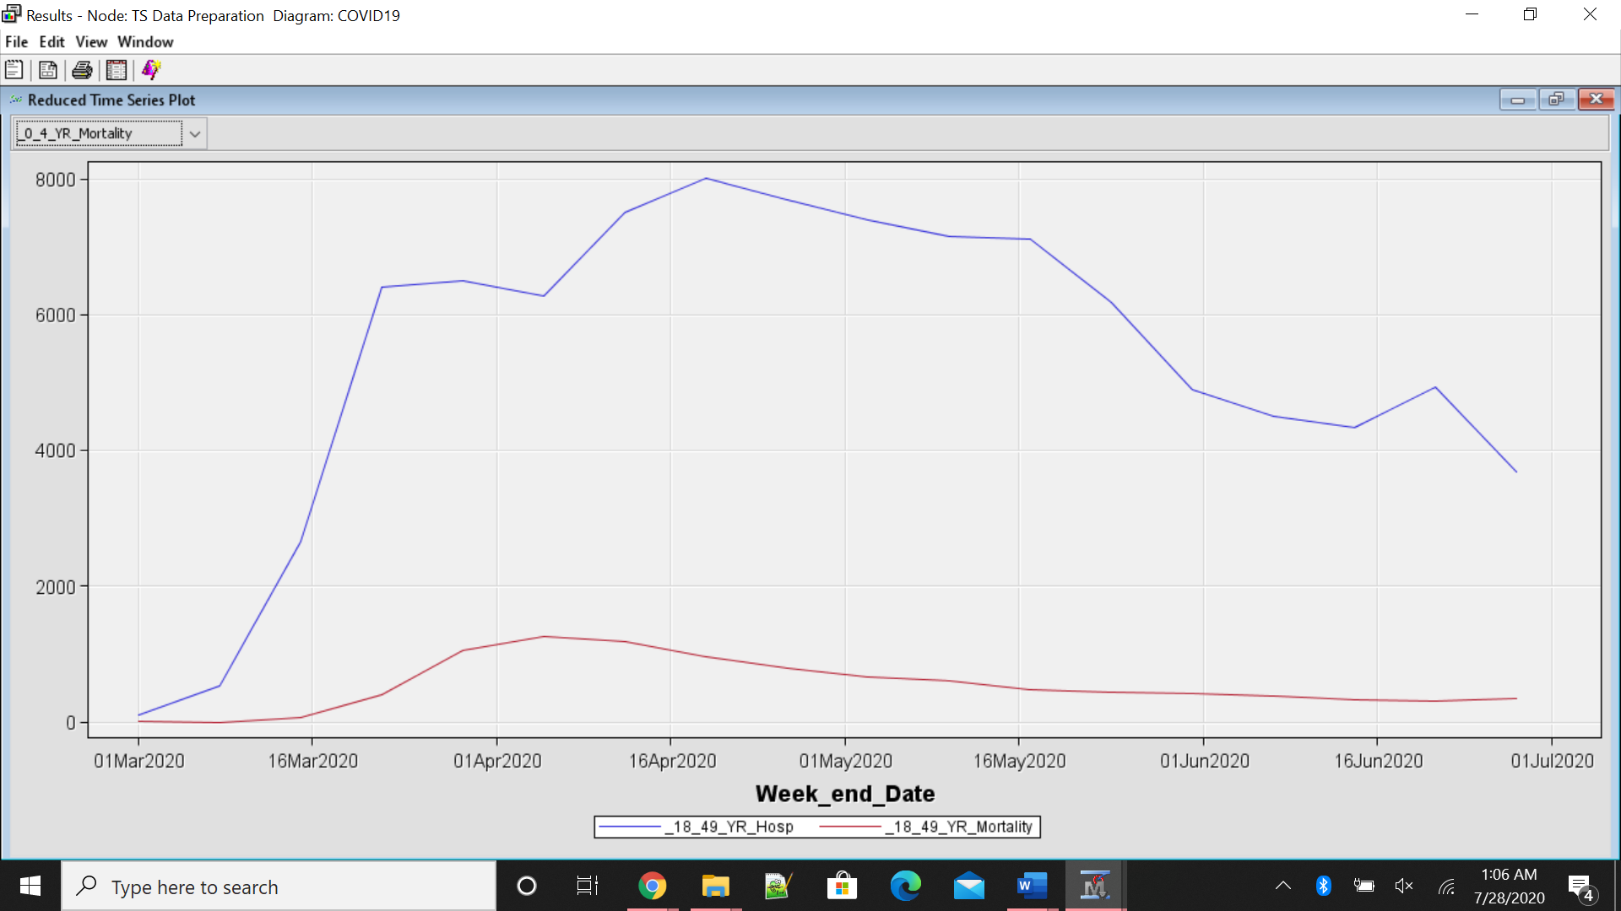

The following image shows the comparison of hospitalization and mortality among 50-64 years.

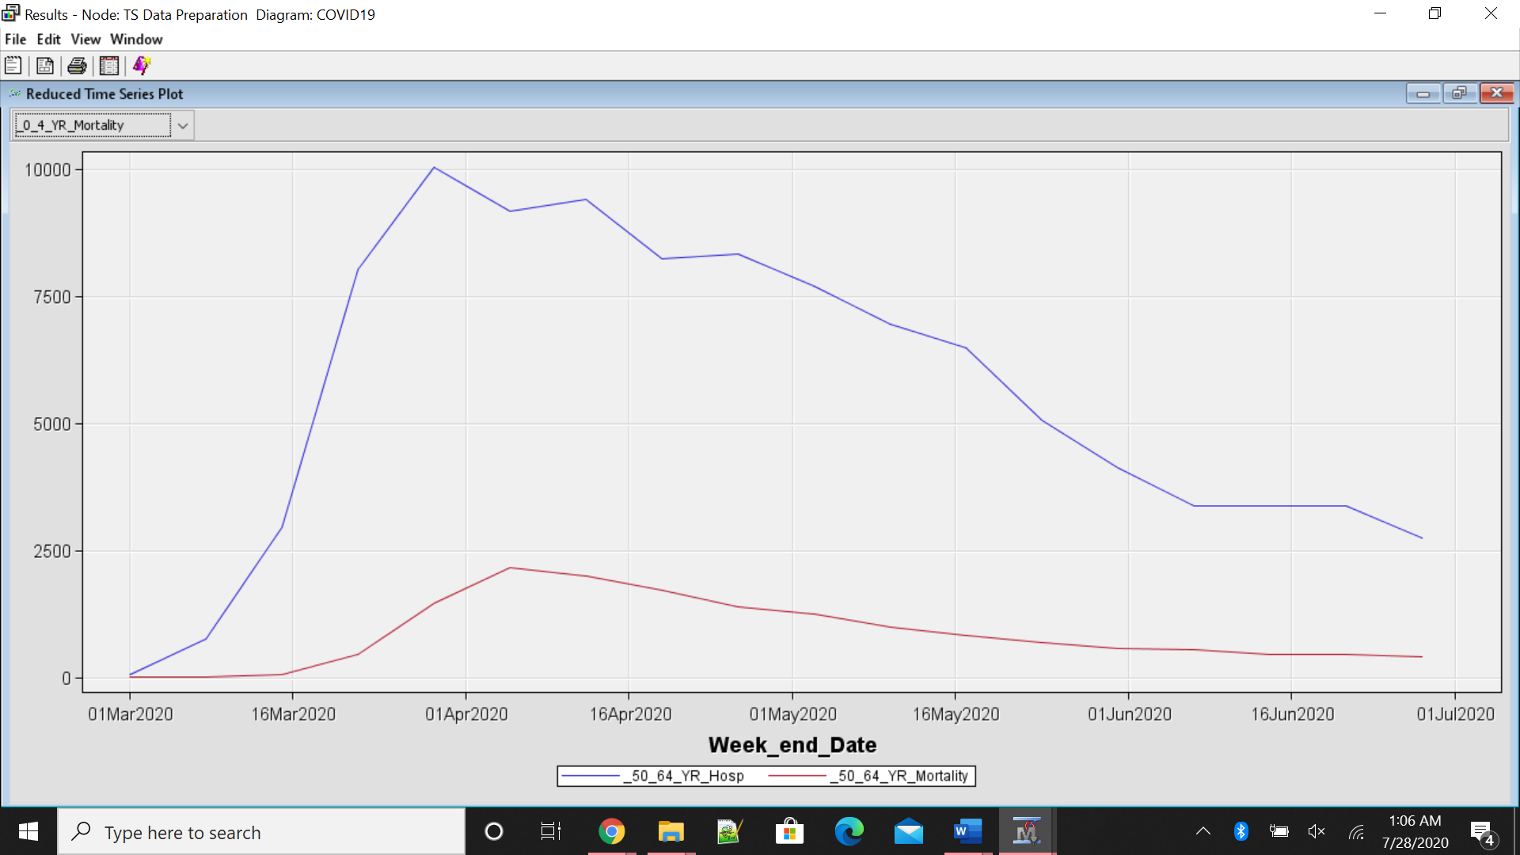

The following image shows the comparison of hospitalization and mortality among 65+ years.

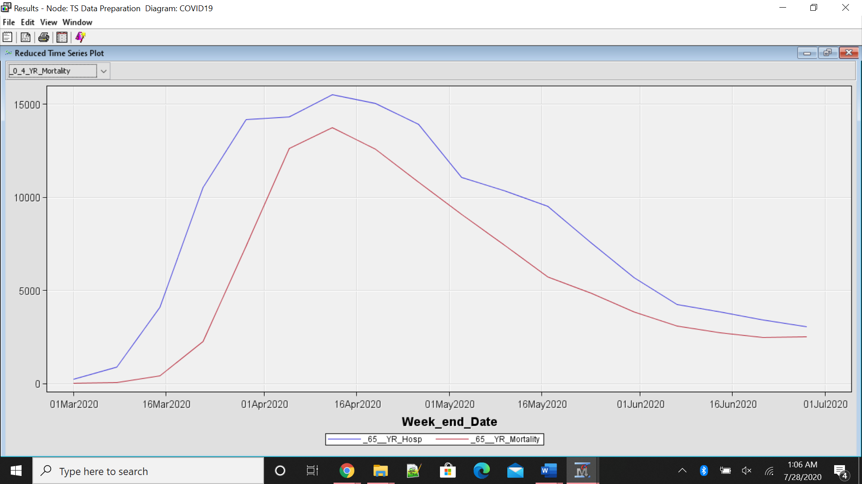

The following image shows the comparison of total hospitalization and mortality cases.

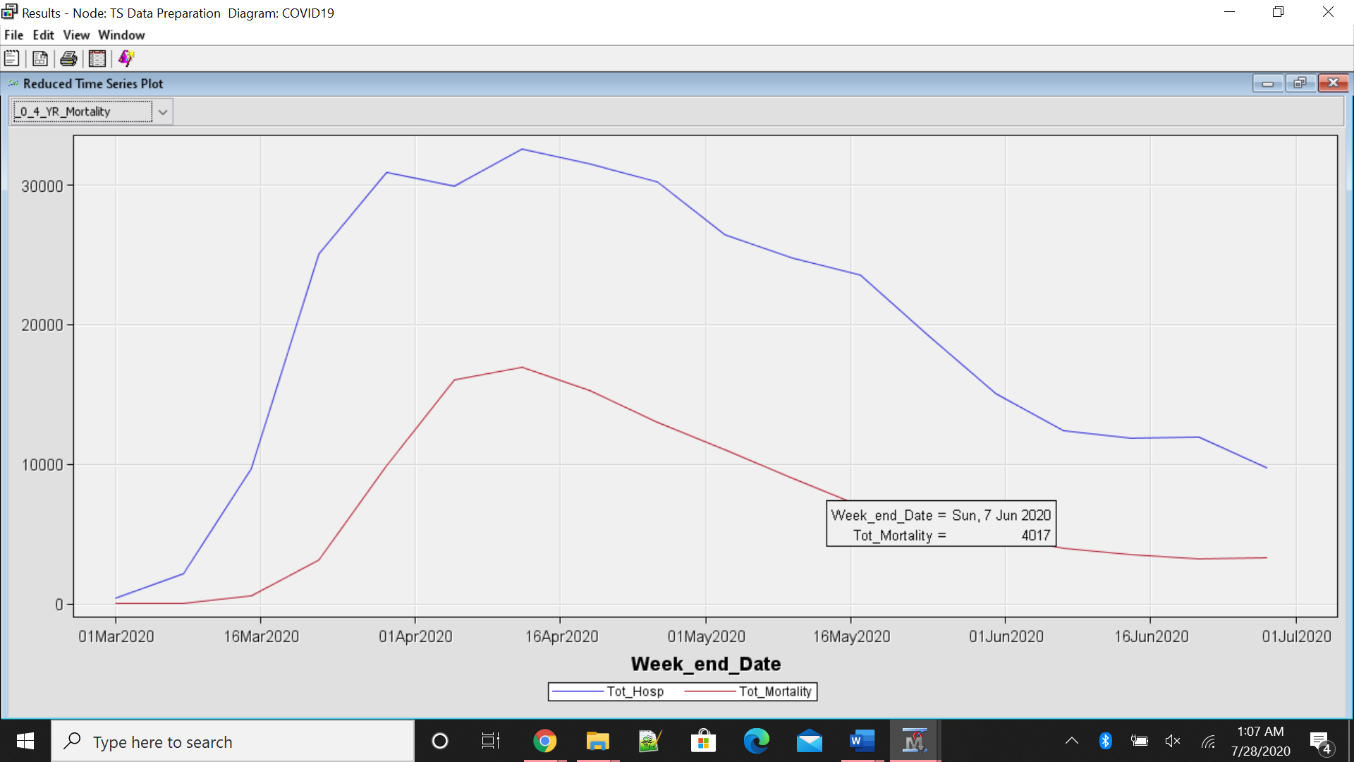

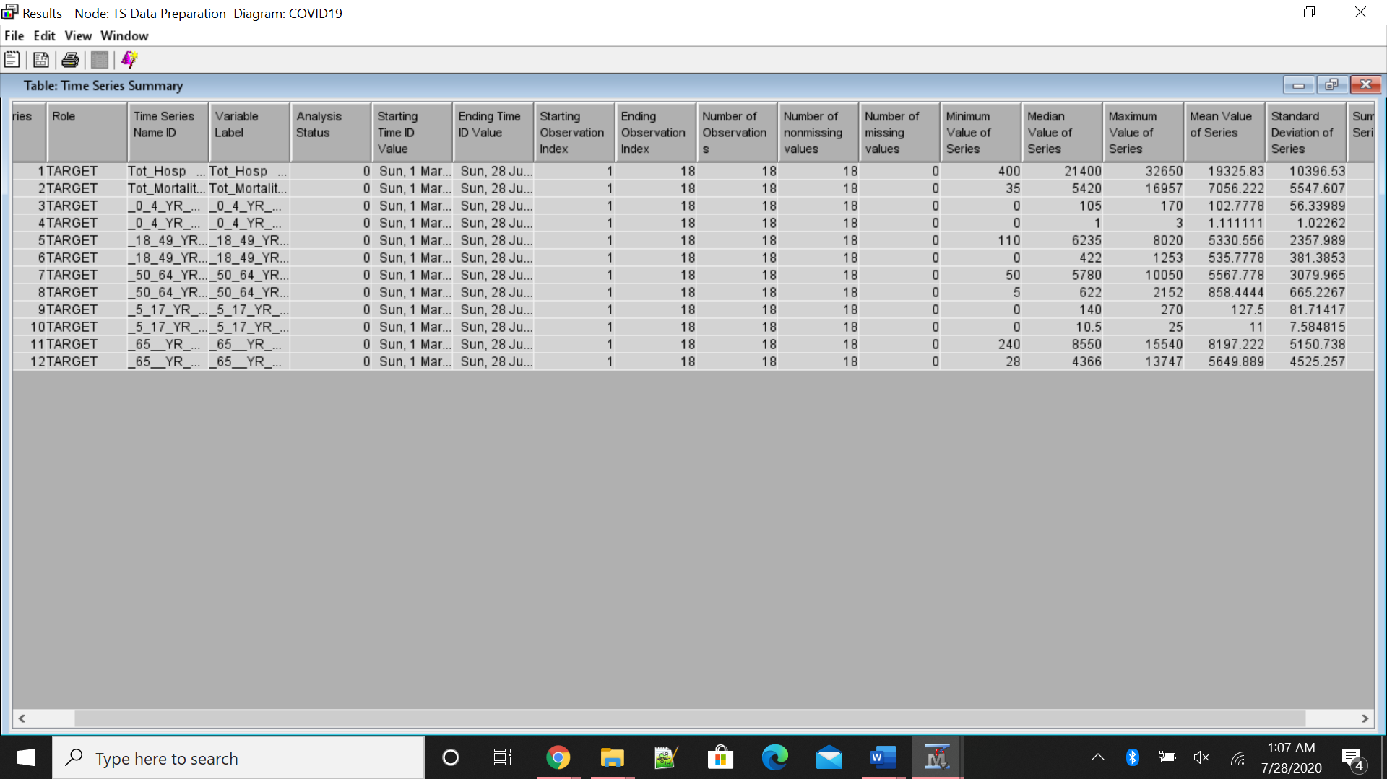

For forecasting the data, we use TS exponential smoothing.

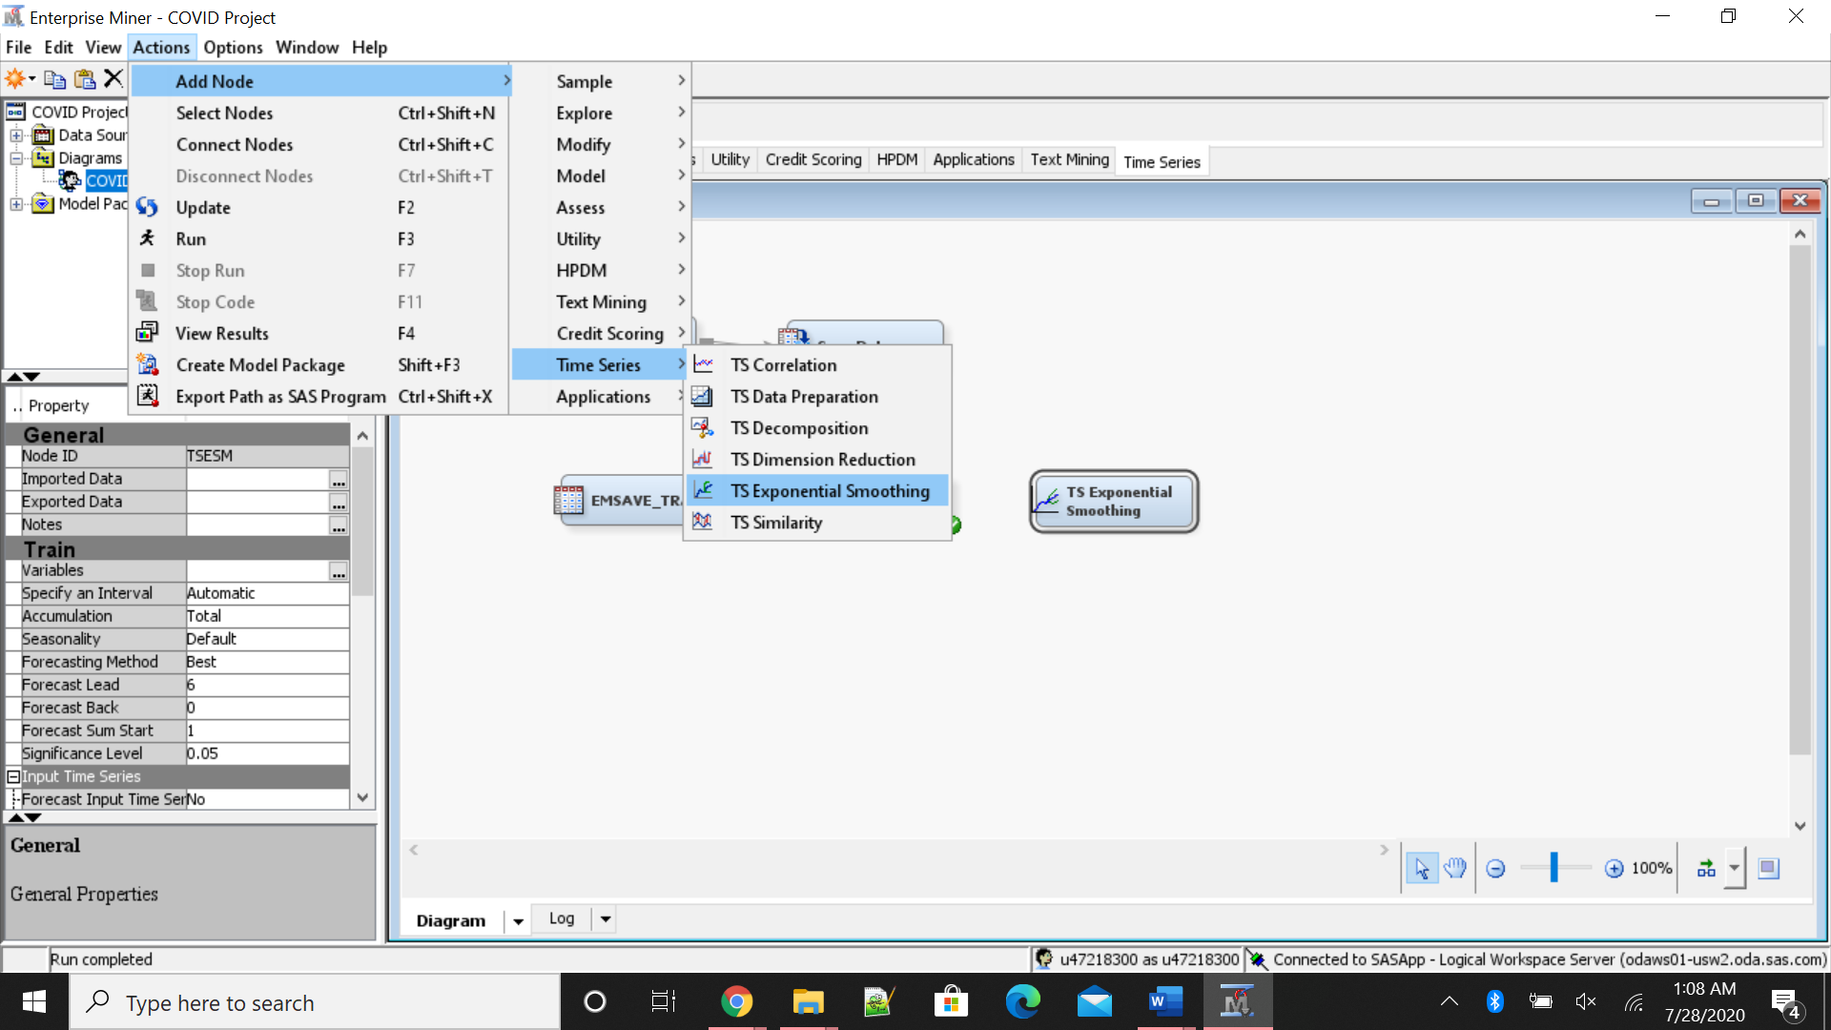

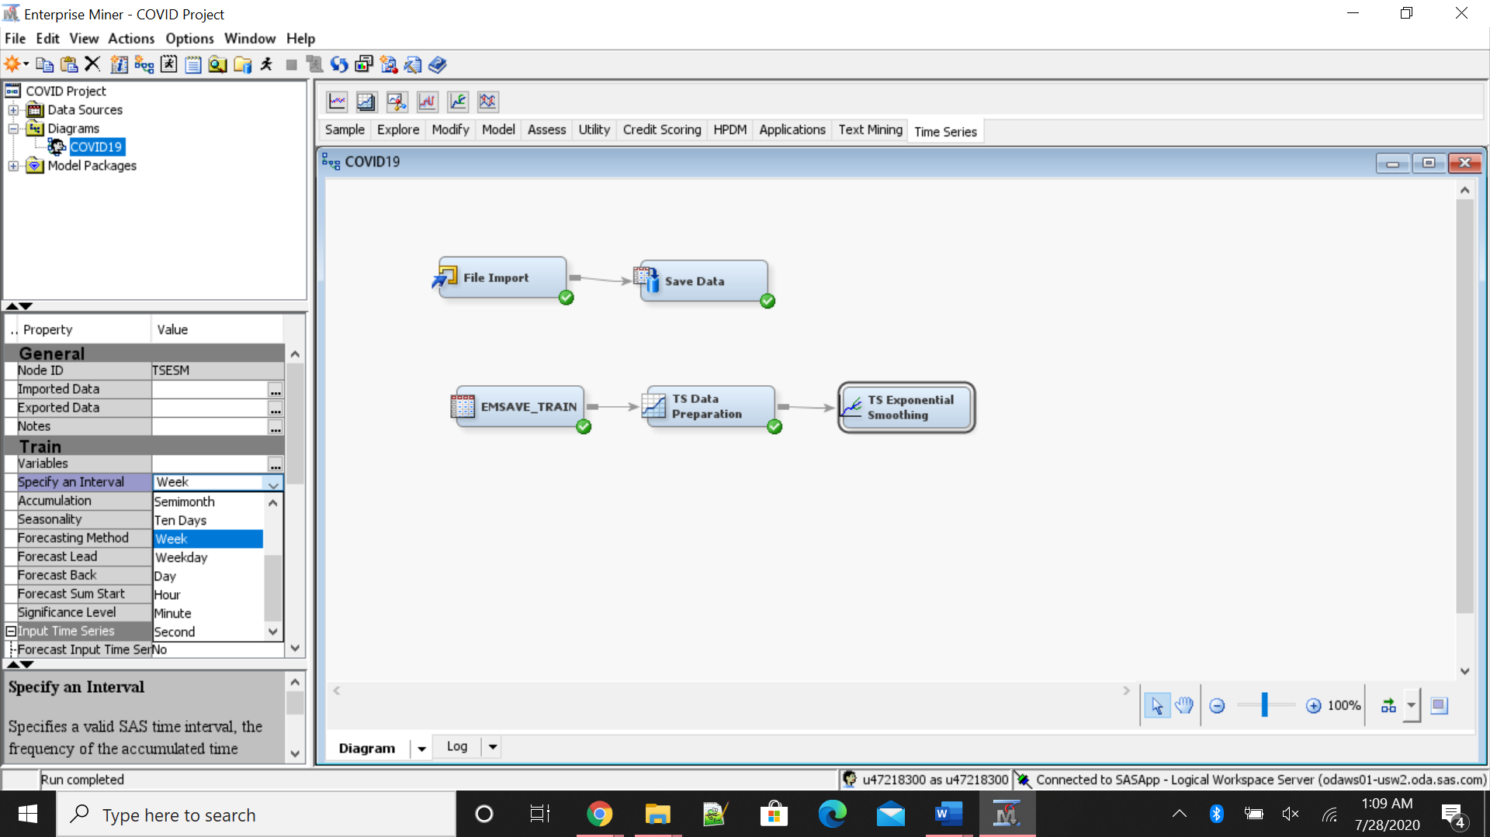

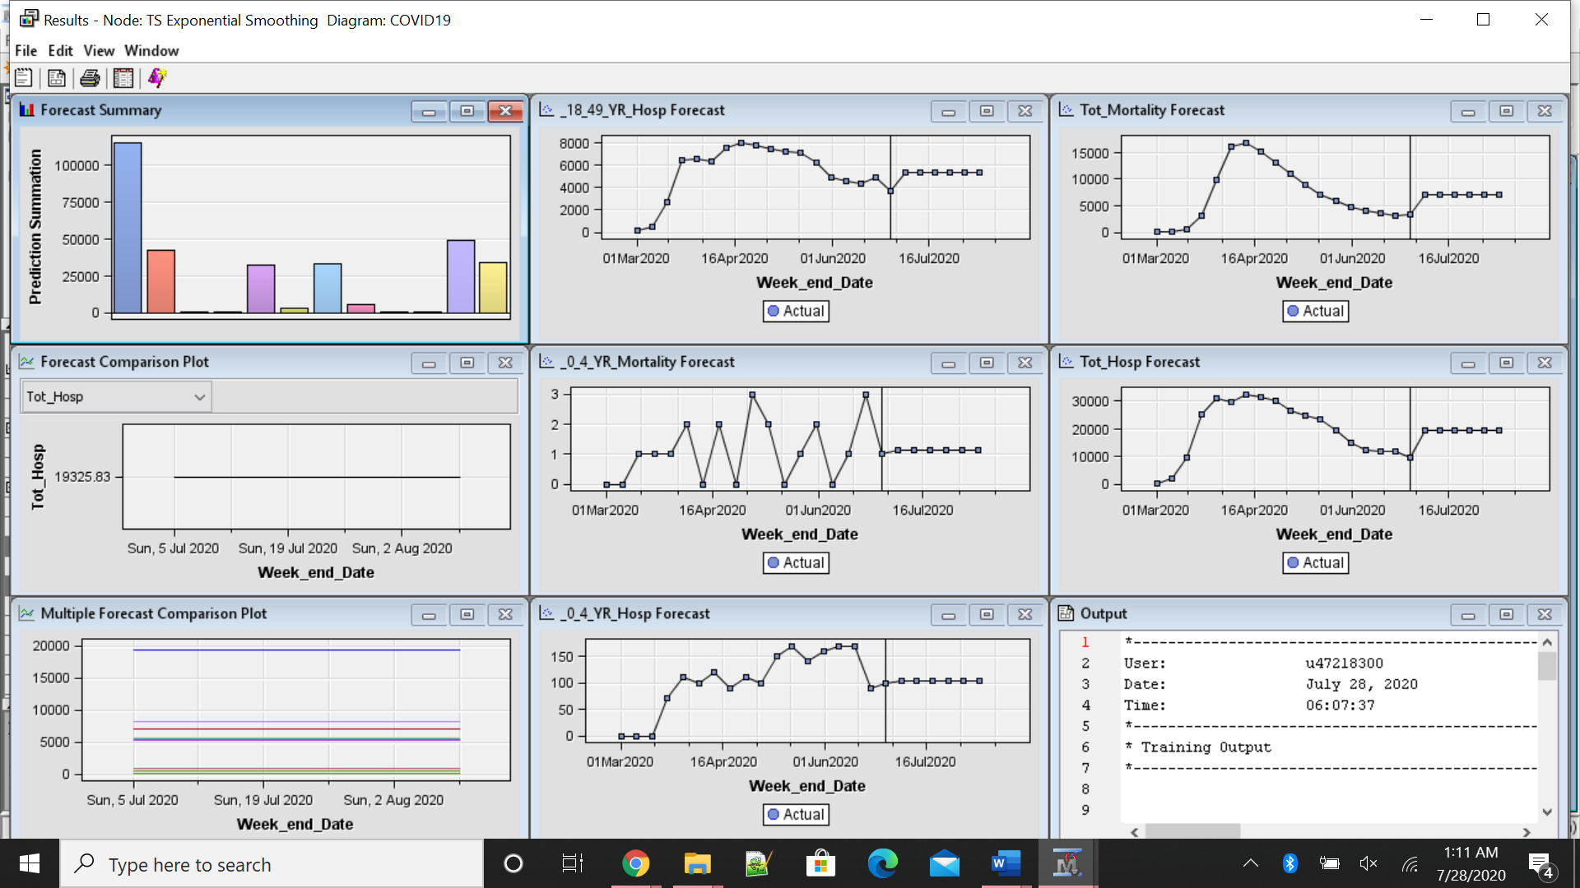

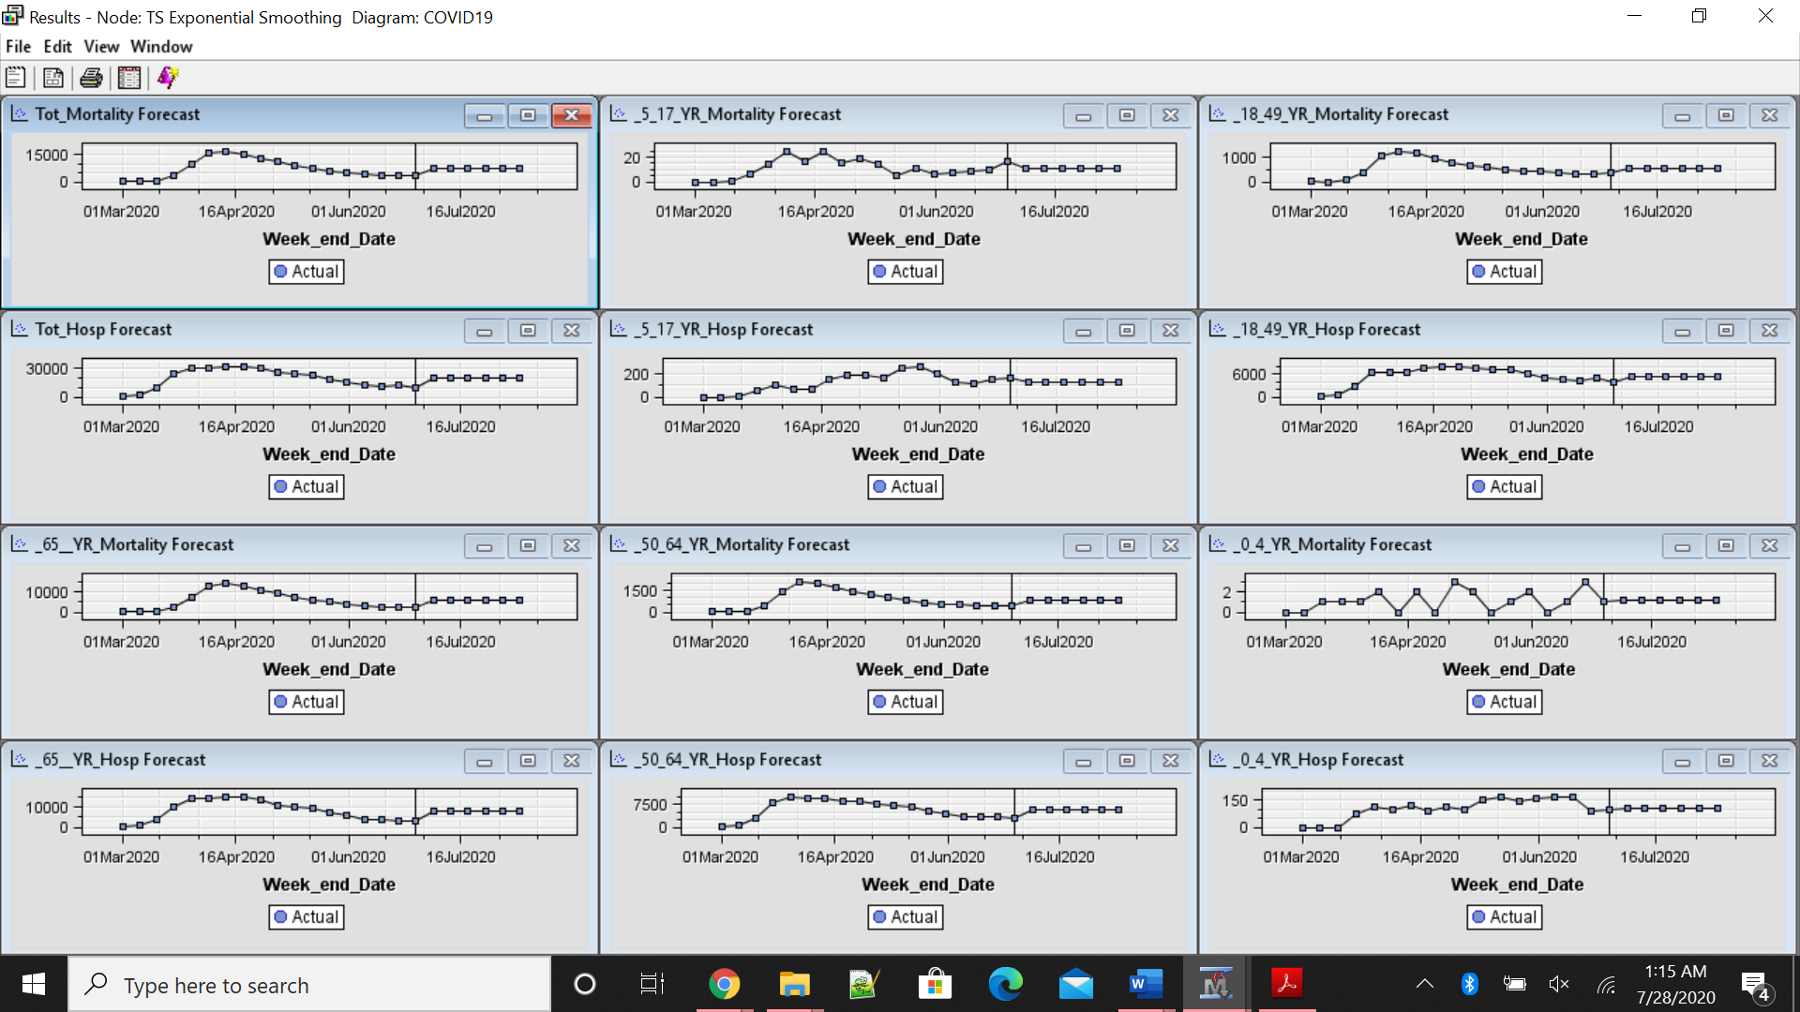

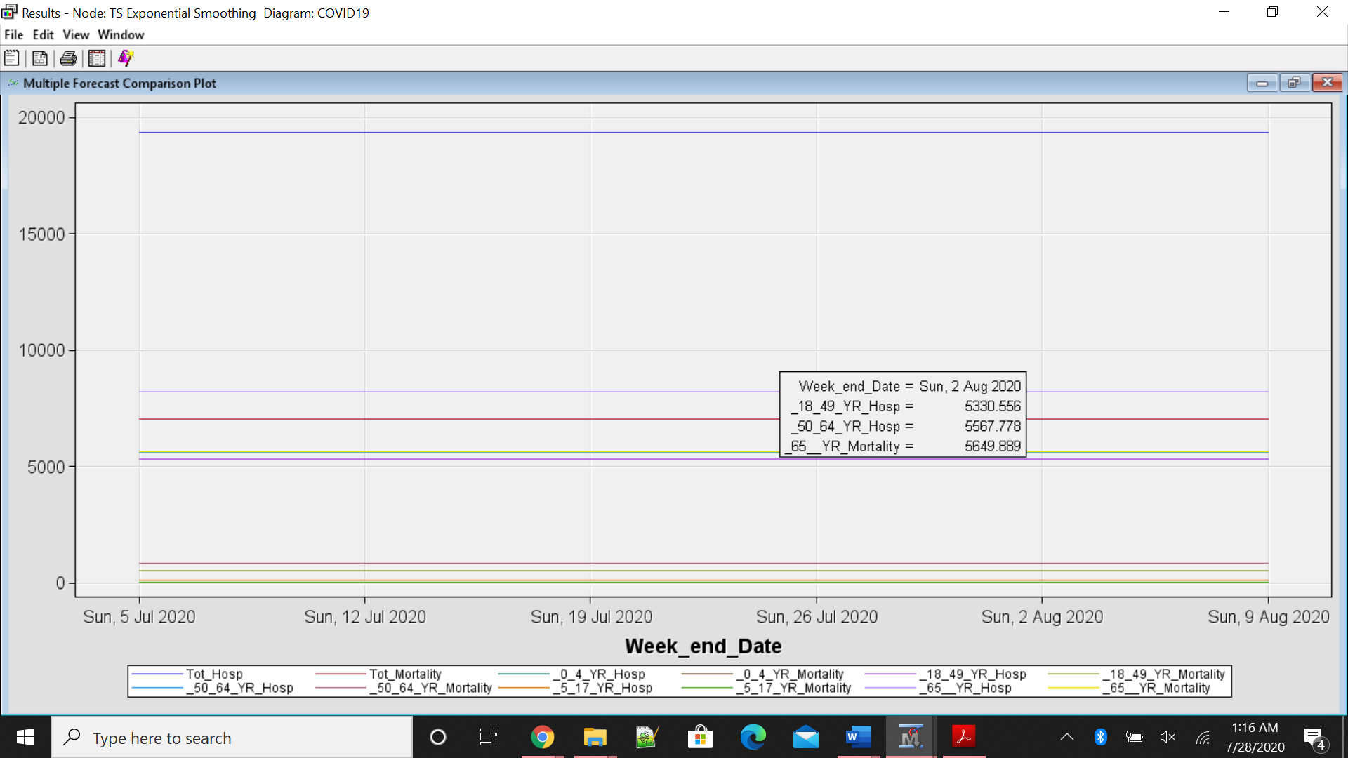

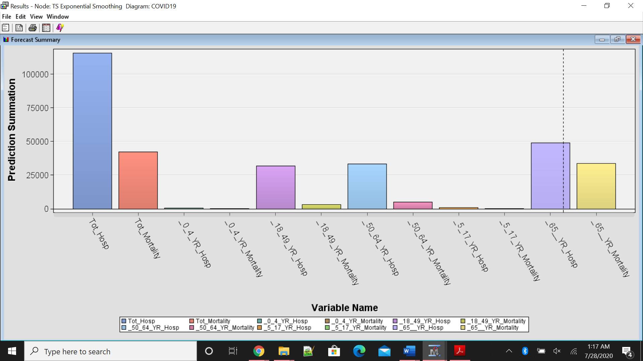

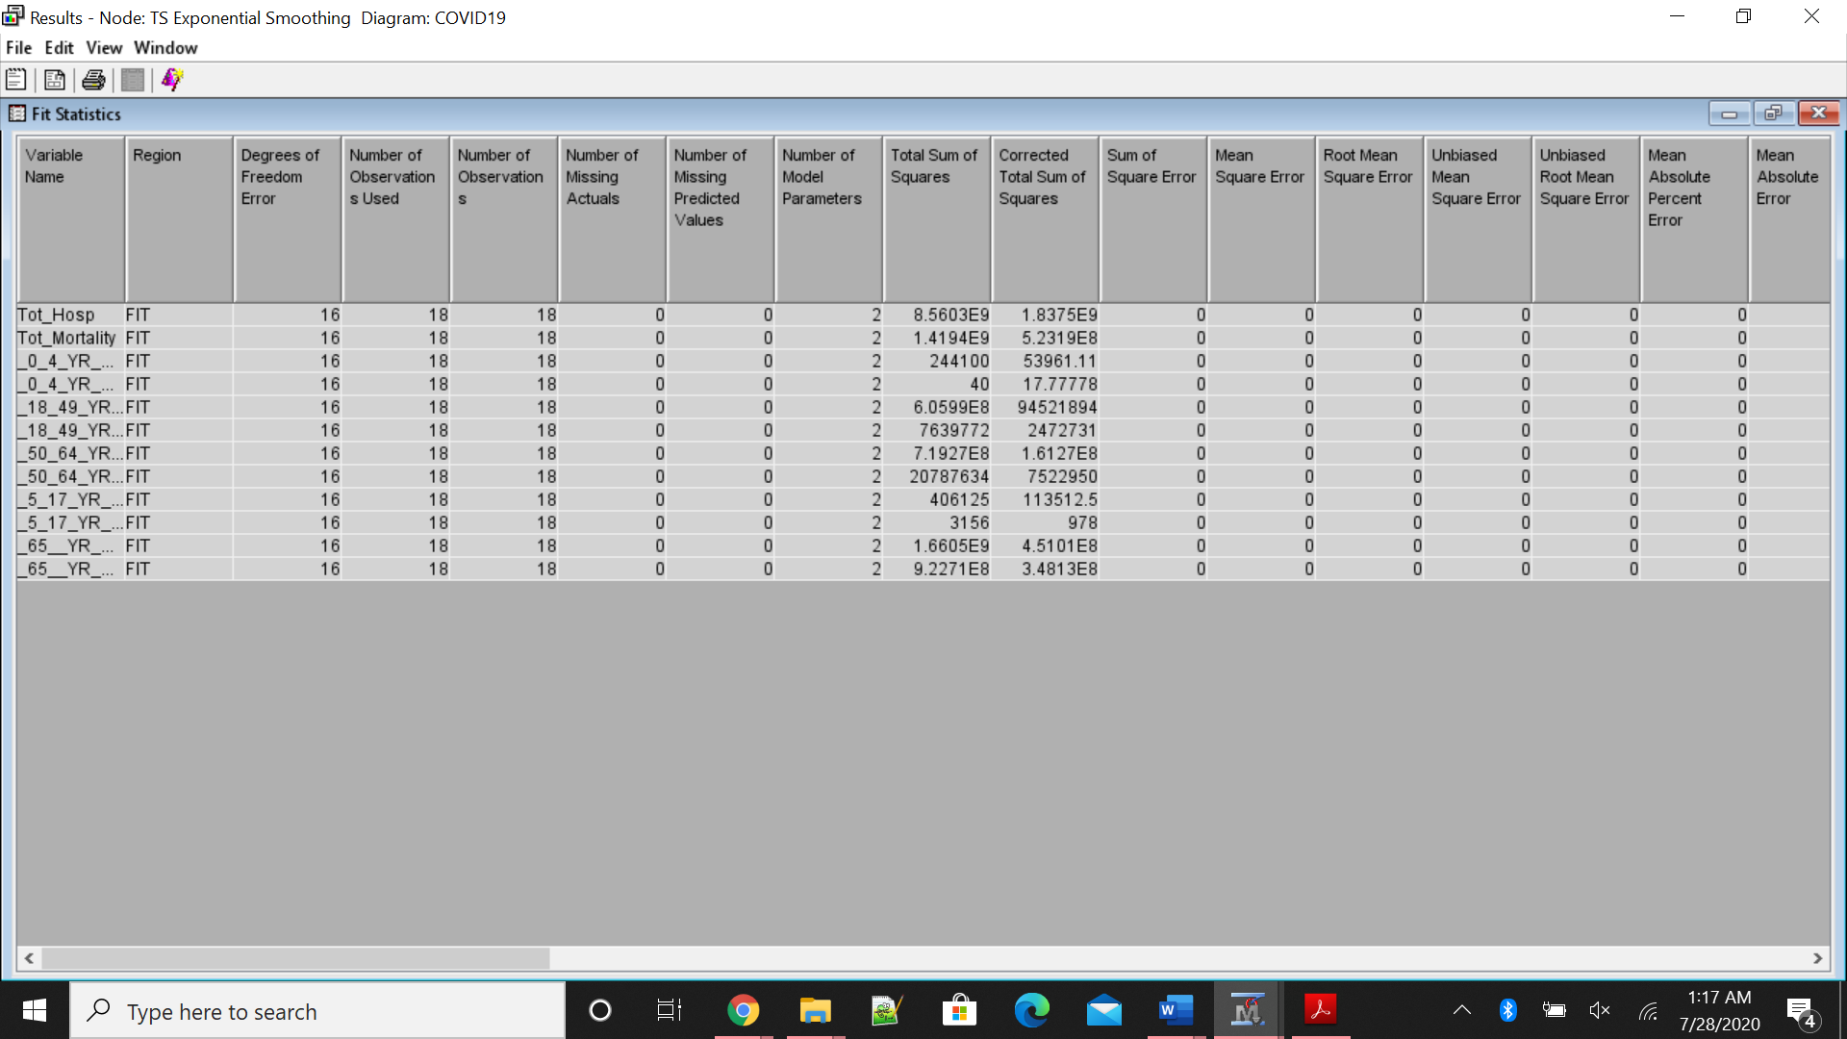

**Step-by-Step Analysis of SAS Studio:**

In SAS studio, upload the file in the respective folder where you want to save. Right click on file and run import file. The excel file or CSV file will create a ‘.sasbat’ file in the respective library. The code and the results are attached with this message, if any one are interested to run the program.

**Result Interpretation:**

In the SAS studio, I have analyzed the data of correlation between various variables to understand the amount of relation there exists between various age groups cases to total cases of both mortality and hospitalization along with correlation between total hospitalizations and total mortality cases. As per the results, the total mortality increases with increase in hospitalization. This is true especially for the population of 65+ years and 50-64 years age compared to that of other age groups. The least vulnerable population being 0-4 years and 5-17 years. The medium range effected are 18-49 years.

**Conclusion:**

In conclusion, there is greater relation of increase in mortality to that of hospitalization especially for the population of more than 50 years of age. Hence, these age groups should isolate and follow all the guidelines provided by the Government to avoid the hospitalization.

**References:**

COVID-19 Hospitalizations. (n.d.). Retrieved July 14, 2020, from <https://gis.cdc.gov/grasp/COVIDNet/COVID19_5.html>

COVID-19 pandemic in the United States. (2020, July 14). Retrieved July 14, 2020, from <https://en.wikipedia.org/wiki/COVID-19_pandemic_in_the_United_States>

Dey, S. K., Rahman, M. M., Siddiqi, U. R., & Howlader, A. (2020). Analyzing the epidemiological outbreak of COVID‐19: A visual exploratory data analysis approach. Journal of Medical Virology, 92(6), 632-638. doi:10.1002/jmv.25743

Ragavi, V., & Geetha, N. (2020). A drill down analysis of the pandemic COVID-19 cases in India using PDE. Materials Today: Proceedings. doi:10.1016/j.matpr.2020.05.595

**APPENDIX – I**

**DATA FILE**

|  |  |  |  |  |  |  |
| --- | --- | --- | --- | --- | --- | --- |
| Week_end_Date | 0-4 YR Hosp | 5-17 YR Hosp | 18-49 YR Hosp | 50-64 YR Hosp | 65+ YR Hosp | Tot Hosp |
| 3/7/2020 | 0 | 0 | 110 | 50 | 240 | 400 |
| 3/14/2020 | 0 | 0 | 540 | 760 | 880 | 2180 |
| 3/21/2020 | 0 | 5 | 2660 | 2950 | 4090 | 9705 |
| 3/28/2020 | 70 | 50 | 6400 | 8030 | 10530 | 25080 |
| 4/4/2020 | 110 | 110 | 6500 | 10050 | 14170 | 30940 |
| 4/11/2020 | 100 | 70 | 6280 | 9170 | 14330 | 29950 |
| 4/18/2020 | 120 | 70 | 7510 | 9410 | 15540 | 32650 |
| 4/25/2020 | 90 | 150 | 8020 | 8250 | 15040 | 31550 |
| 5/2/2020 | 110 | 190 | 7700 | 8340 | 13930 | 30270 |
| 5/9/2020 | 100 | 190 | 7390 | 7700 | 11070 | 26450 |
| 5/16/2020 | 150 | 170 | 7150 | 6960 | 10350 | 24780 |
| 5/23/2020 | 170 | 250 | 7120 | 6490 | 9520 | 23550 |
| 5/30/2020 | 140 | 270 | 6190 | 5070 | 7580 | 19250 |
| 6/6/2020 | 160 | 200 | 4900 | 4130 | 5710 | 15100 |
| 6/13/2020 | 170 | 130 | 4510 | 3370 | 4230 | 12410 |
| 6/20/2020 | 170 | 120 | 4340 | 3370 | 3850 | 11850 |
| 6/27/2020 | 90 | 150 | 4940 | 3370 | 3420 | 11970 |
| 7/4/2020 | 100 | 170 | 3690 | 2750 | 3070 | 9780 |

|  |  |  |  |  |  |  |
| --- | --- | --- | --- | --- | --- | --- |
| Week_end_Date | 0-4 YR Mortality | 5-17 YR Mortality | 18-49 YR Mortality | 50-64 YR Mortality | 65+ YR Mortality | Tot Mortality |
| 3/7/2020 | 0 | 0 | 2 | 5 | 28 | 35 |
| 3/14/2020 | 0 | 0 | 0 | 6 | 46 | 52 |
| 3/21/2020 | 1 | 1 | 64 | 66 | 432 | 564 |
| 3/28/2020 | 1 | 6 | 396 | 463 | 2273 | 3139 |
| 4/4/2020 | 1 | 14 | 1055 | 1457 | 7404 | 9931 |
| 4/11/2020 | 2 | 25 | 1253 | 2152 | 12641 | 16073 |
| 4/18/2020 | 0 | 17 | 1186 | 2007 | 13747 | 16957 |
| 4/25/2020 | 2 | 24 | 959 | 1728 | 12588 | 15301 |
| 5/2/2020 | 0 | 15 | 787 | 1382 | 10836 | 13020 |
| 5/9/2020 | 3 | 19 | 666 | 1251 | 9081 | 11020 |
| 5/16/2020 | 2 | 14 | 598 | 983 | 7410 | 9007 |
| 5/23/2020 | 0 | 5 | 481 | 828 | 5715 | 7029 |
| 5/30/2020 | 1 | 11 | 431 | 683 | 4872 | 5998 |
| 6/6/2020 | 2 | 6 | 413 | 561 | 3860 | 4842 |
| 6/13/2020 | 0 | 7 | 384 | 548 | 3078 | 4017 |
| 6/20/2020 | 1 | 8 | 323 | 465 | 2725 | 3522 |
| 6/27/2020 | 3 | 10 | 302 | 449 | 2465 | 3229 |
| 7/4/2020 | 1 | 16 | 344 | 418 | 2497 | 3276 |
|  |  |  |  |  |  |  |